Creating a GO slim using DAG-Edit
A. Introduction
With the continual increase in range and depth of coverage of the Gene Ontologies (there are now approximately 17,700 terms within the three ontologies), users can find it difficult to gain a overview of the sections of the ontologies that interest them or see the activities/subcellular locations that a set of gene products have been annotated to.
GO slims can provide users with such a perspective. These slims are cut-down versions of the complete GO, containing a selected subset of GO terms. If users select terms that are high-level and wide-ranging, a slim can provide an overview of part or all of the GO.
GO slims have proved to be particularly useful for providing a summary of the GO annotations of a proteome, MicroArray, or cDNA collection when broad classification of gene product function is required.
This tutorial will make use of the DAG-Edit ontology editor, a generic tool developed to aid creation and manipulation of ontologies, which has been developed by the GO Consortium. This software is freely available for download (http://sourceforge.net/projects/geneontology/).
For today’s tutorial the DAG-Edit software will have been already loaded onto your computers and an icon for this tool should be visible on your desktop.

The version of DAG-Edit that this tutorial uses is: 1.419 rev3.

B. Starting up the DAG-Edit tool and viewing the GO ontologies

- Double click on the desktop icon on for the DAG-Edit tool:



- After DAG-Edit has loaded, you will need to load up the Gene Ontologies.

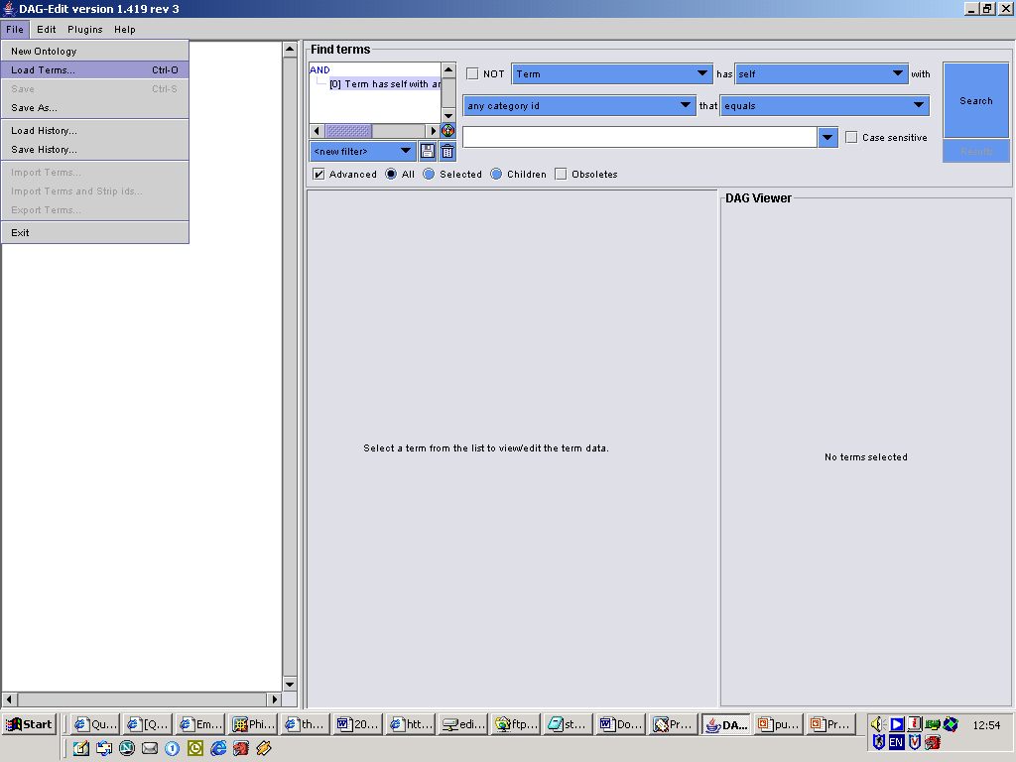
Go into the file menu at the top of the screen and within the drop-down menu click on ‘Load terms..’.

- This will bring up a ‘Load terms’ window similar to the one shown below.

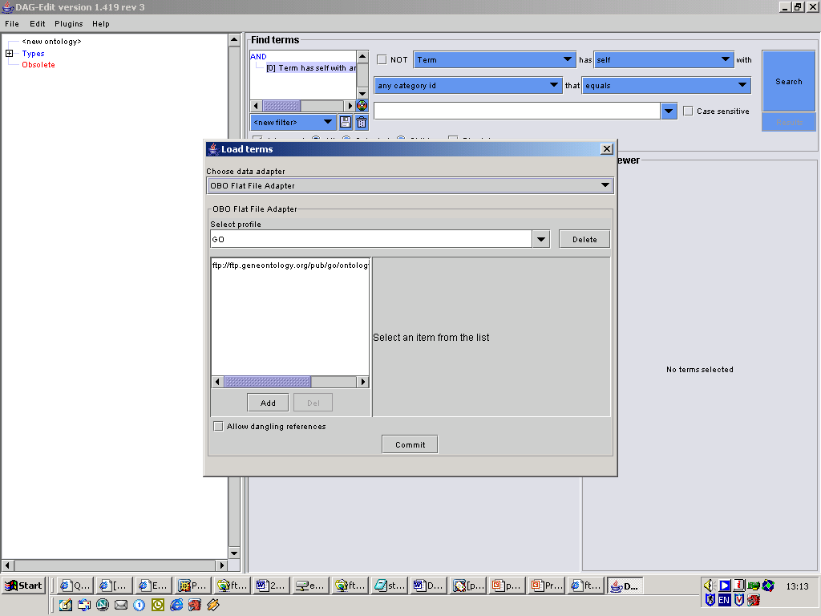

  - If GO has already been added to the ‘Load terms’ box, then the abbreviation ‘GO’ should be found in the ‘Select profile’ text box. If this is the case, you only need to click on ‘Commit’.

  - Otherwise:
    - ensure that the option for ‘Choose data adapter’ has been set to ‘OBO Flat File Adapter’
    - you will need to delete the ‘<new profile>’ text in the ‘Select Profile’ box and replace it with the name of the ontologies we are about to load – so type ‘GO’.
    - Click the ‘Add’ button.
    - Replace the ‘<new path>’ text in the ‘Path or URL’ text box with the path for the Gene Ontologies ftp site:

ftp://ftp.geneontology.org/pub/go/ontology/gene_ontology.obo

    - Click on ‘Commit’

(NOTE: When you have entered the ftp address, make sure you don’t press the ADD button again)

- You should see the file being loaded up into the DAG-Edit tool – which takes a minute or so.

- Once the ontologies have loaded, the ‘Load Terms’ dialogue box will have disappeared, and the roots of the three GO ontologies will have appeared on the left of the screen:
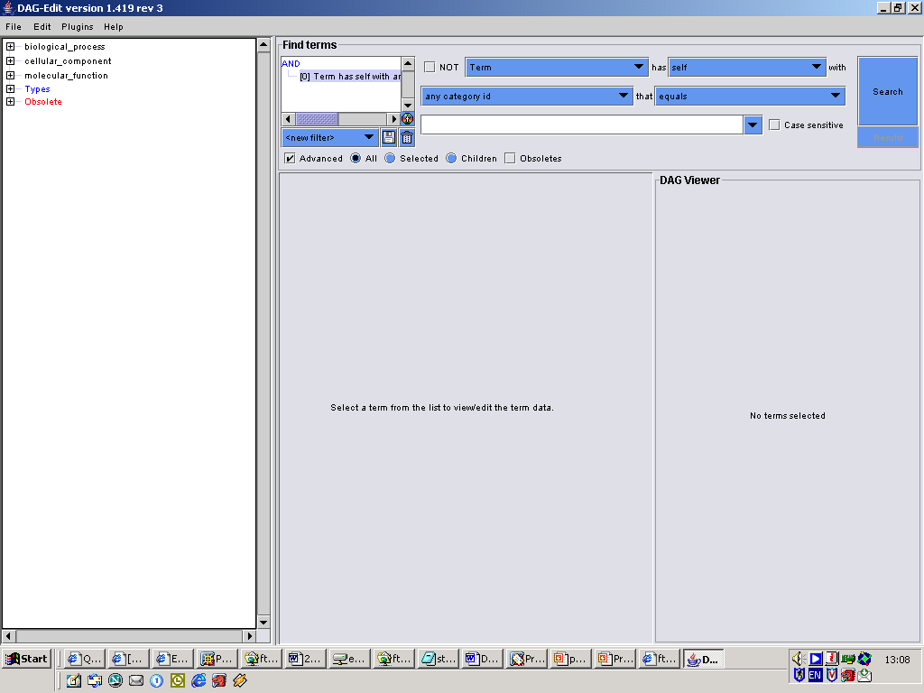

C Browsing and Searching the GO using DAG-Edit

- Where there are + symbols to the left of these GO terms, by clicking on these symbols you will be able to expand the view of the ontologies:

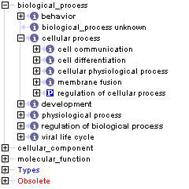

When clicking on any of the GO terms, information on the GO term’s ID, definition, synonyms etc will appear in the centre panel.

- Searching the GO

You can search for terms using the ‘Find terms’ facility on the top right-hand side of the tool.

Unclick the ‘Advanced’ button on this panel – this will make searching simpler.

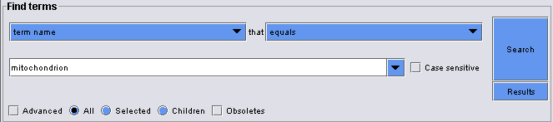

- How many terms start with the word ‘mitochondrion’?

Q. How many terms contain the word ‘mitochondrion’ any where in the term name?

Q. How many terms contain the synonym ‘membrane’?

D Creating a GO Slim.

- Firstly you will need to name your new GO slim:

  - Click on the Plugins menu on the tool bar at the top, and select the second option on the drop-down menu - ‘Category Manager Plugin’.

  - Within the Category Manager Plugin box that appears you will see a number of important GO slims that are tagged in the GO to ensure they are kept up-to-date.

  - To make a new slim, click the ‘Add’ button and add a short name for your new GO (to replace NEWCAT), as well as a full name (to replace <new term category>) – you could use your name or a biological topic.
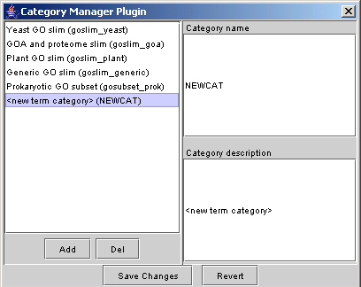

  - Press ‘Save Changes’ and close the Category Manager Plugin box.

- Before adding terms to your GO slim it is helpful to configure DAG-Edit so that you can see which terms you’ve already added, using a ‘renderer’ which will highlight the chosen GO terms in a different colour.

To add this renderer:
  - Go to the ‘Find terms’ section of the tool, on the right hand side of the Editor (as pictured below)

  - Click the tick box for the ‘Advanced’ search option.

  - Just above the floppy disc icon, there is a colourful, round icon (indicated by the arrow in the picture below), click on this to bring up a window showing the default values for the rendered view - tick the box next to ‘Change color’ )a box showing the default highlight colour will appear), then close this window.

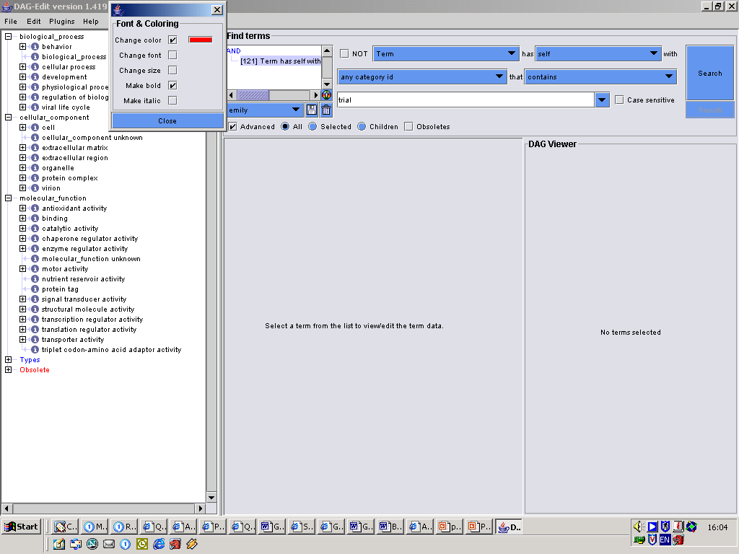

  - Within the ‘Find terms’ panel, click on the middle right drop-down menu (which provides options such as: ‘any id’, ‘term name’…) and choose the ‘any category id’ option located in the middle of the list (the menu options within the Find terms panel should be the same as those shown in the figure below).

  - Type the short name (e.g. test) if your newly created slim into the search box and save it (using the icon of a floppy disk located to the left of the box).
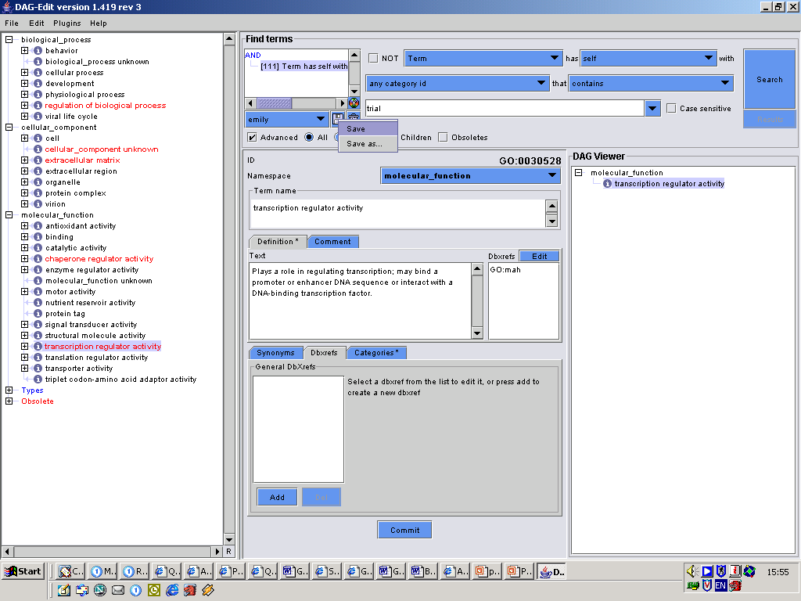

  - A box will appear asking for a Filter name, choose a name such as the name of your slim, and click OK.

  - Click on the text within the white box (directly beneath the Find Terms heading) and drag it across to the term viewer panel, (which shows the DAG of the Gene Ontologies).
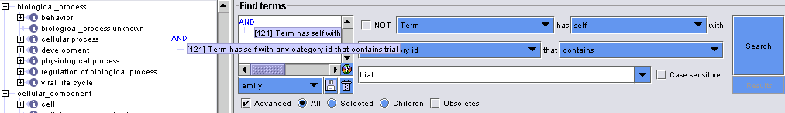

  - When you release your mouse button, you be faced with three display choices:
    - Add as filter & renderer
    - Add as renderer
    - Add as filter
      - choose option ‘Add as renderer’.

Now any GO term selected for your GO slim will have a red font.

- Now you are ready to add a GO term to your slim set.

  - In the term viewer planel, find a term you would like to include in the slim and click on its name.

  - Click on the ‘Categories*’ tab, situated in the middle bottom part of the editor.

  - You will see you GO slim listed here (along with the other GO slims maintained by GO (see picture on the next page)).

  - Click the tick box next to your GO slim.

  - Click the ‘Commit’ button located at the bottom middle of the tool.
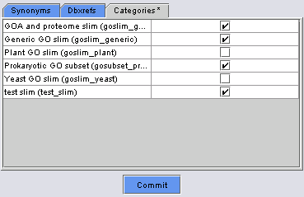

- Repeat the previous steps described in 10. for each GO term you would like to be included within your GO slim.

NOTE: Remember that you could make up a slim using high, broad-ranging terms to provide a broad overview of the GO categories or you could design a slim to be specific to species or to particular areas of the ontologies.

E. Viewing Your Slim

- If you only wanted to see terms you have selected for your GO slim, you can repeat the actions described in step 9, but instead of choosing the option ‘Add as renderer’, instead click ‘Add as filter’.

- To return to the whole GO view, go down to the bottom right corner of the term viewer panel click on the small ‘FR’ button and select the ‘Remove filter’ option that appears.

F. Saving your GO slim:

- Click on the ‘Save As’ option within the File menu on the toolbar, and the ‘Save As’ window should then appear.

- Click on the ‘gene_ontology’ heading in the white box on the left-hand side of this box and replace the ftp://ftp.geneontology.org/pub/go/ontology/gene_ontology.obo ftp address with the file path of where you would like to save your GO slim.
e.g. H:\test_slim_with_GO.obo

- You have two options of formats to save your slim in:

    - You can tick the box next to ‘Filter saved ontology?’ – which will save only the GO terms you have selected to be in your slim.

    - By not selecting ‘Filter saved ontology?’ the whole GO will be saved, and each term selected by you for the slim will be tagged – which you can later use as a filter to only view your slim. This option is recommended, as it allows you to modify your slim in the future.

- Click ‘Commit’ to save.

