1. Staff:
Curators: Alexander Diehl, Harold Drabkin, David Hill, Li Ni, TB Reddy
Analyst: Mary Dolan,
PIs: Judith Blake, Janan Eppig, Jim Kaden, Joel Richardson, Martin Ringwald,
Summer Students: Daniel Lieberman

2. Annotation Progress
We continue our efforts at hand annotation for genes currently without GO annotation (Li), and are also focusing on genes associated with mouse models of human diseases (David, Harold) by concentrating on genes linked to OMIM records and/or those that have alleles associated with phenotypes. Another area of concentration are those genes with little or no mouse experimental literature, but have demonstrated orthology to human and/or rat genes that do have experimental literature. We currently have over 17,000 genes with some annotation.

MGI GO STATS as of March 10, 2006

Annotation Type | 24_Mar_05 | 10_Mar_06 | Change | % Change
Total Genes annotated: | 16145 | 17085 | 940 | 5.8
Total Hand Annotation
Number of Genes | 7914 | 8999 | 1085 | 13.7
Orthology: | 308 | 410 | 102 | 33.1
“IEA”
SwissProt to GO | 11096 | 12646 | 1550 | 14
Interpro to GO | 5643 | 6855 | 1212 | 21.4
EC to GO | 650 | 1450 | 800 | 123
GO Fish | 1984 | 1972 | -12 | -0.6

Annotation Methods:

Annotation Strategies:

We have begun a systematic look at unannotated or under-annotated genes related to mouse models of human diseases. Two approaches that are being used is to look at genes that have any link to an OMIM record (currently 32) , and genes that have mutant alleles with know phenotypes (currently 1850). An additional focus of annotation is to use non-mouse experimental literature from organisms with orthology to mouse genes. Presently, we are restricting this rat and human genes.

We have begun to track genes where the mouse literature has been exhausted for annotation. Since beginning this effort in December, we have recorded 110 genes that have been "fully annotated".

4. Publications:
M.E. Dolan, L. Ni, E. Camon, and J.A. Blake, “A procedure for assessing GO annotation consistency”, Bioinformatics 2005, 21(Suppl 1):i136-i143.

Mary E. Dolan and Judith A. Blake, Using Ontology Visualization to Coordinate Cross-species Functional Annotation for Human Disease Genes (accepted for publication) International Journal of Bioinformatics Research and Applications (IJBRA), Special Issue on "Ontologies for Bioinformatics", Volume 3, Issue 1(2007, in press).

Judith A Blake and Carol J Bult. “Beyond the data deluge: Data integration and bio-ontologies”. Journal of Biomedical Informatics (2006, in press).

5. Other Highlights

Graphical Displays
GOgraphEX (see poster), a web browser visualization tool for ontologies and annotations, is available at MGI: http://proto.informatics.jax.org/prototypes/gograph/ . Presenting terms and annotations within the ontology relationship structure provides a better understanding of terms and of annotations.
MGI GO graphs
These graphs present a graphical view (in addition to the Text and Table views on the GO classifications page) of MGI GO annotations for any gene .http://proto.informatics.jax.org/prototypes/gograph/MGIonly/
GO Comparative Graphs
These graphs present a comparison of GO annotations made to mouse-human-rat MGI curated orthology sets http://proto.informatics.jax.org/prototypes/gograph/GOComparativeGraphs/. Figure 1 at the end shows a sample graph.
OBO interactive graphs
1. GO http://proto.informatics.jax.org/prototypes/gograph/GO_Graphs/
2. Adult mouse anatomical dictionary (also includes EMAP and NCI Thesaurus) http://proto.informatics.jax.org/prototypes/gograph/MA_Graphs/
3. Mammalian phenotype http://proto.informatics.jax.org/prototypes/gograph/MP_Graphs/
4. Cell type http://proto.informatics.jax.org/prototypes/gograph/CL_Graphs/
5. Sequence http://proto.informatics.jax.org/prototypes/gograph/SO_Graphs/
The interactive (SVG) DAGs allow you to see both the ancestors of a selected term and its immediate children and grandchildren. Clicking on any node in the graph takes you to a new graph specific for that node. The SVG viewer also allows zooming in and out and searching via a right-click menu.

Complex Ontology Development
A major focus of the past year has been our efforts to improve the representation of immunology in the GO biological_process ontology, in collaboration with Drs. Jamie Lee and Richard Scheuermann, which included co-organization of the GO Content Meeting held at TIGR in November 2005 at which the immunology proposals were discussed with a mixed group of immunologists and GO experts.

We are now approaching the final stage in this project, which both includes a major revision to the structure of the GO biological_process ontology and the addition of 345 new terms. Also folded into this project are long awaited changes in the response and detection terms.

In conjunction with this work, we have also undertaken a revision of the hematopoietic section of the Cell Ontology in order to allow proper alignment of the two ontologies and correct and expand the immunologically related cell types in the Cell Ontology. A total of 80 new cell types have been created. This work is finished, but awaits final incorporation in the main Cell Ontology pending outside review.

As part of our effort to annotate disease-related genes, we have expanded the branch of the ontology dealing with blood-pressure regulation. We have added ~60 terms for this branch. We also have contributed to the further refinement of the development node, including the neurogenesis and myogenesis branches.

Outreach:
As part of our effort to increase collaboration with other groups interested in using the GO and other ontologies for the purpose of annotating genes of immunological interest, we hosted Dr. Jamie Lee of the University of Texas Southwestern Medical Center at Dallas Department of Pathology, to learn about GO annotation practices and assist in our efforts in improving the representation of immunology in the GO. Jamie works with Dr. Richard Scheuermann on the ImmPort Immunology Database and Analysis Portal.

Figure 1:
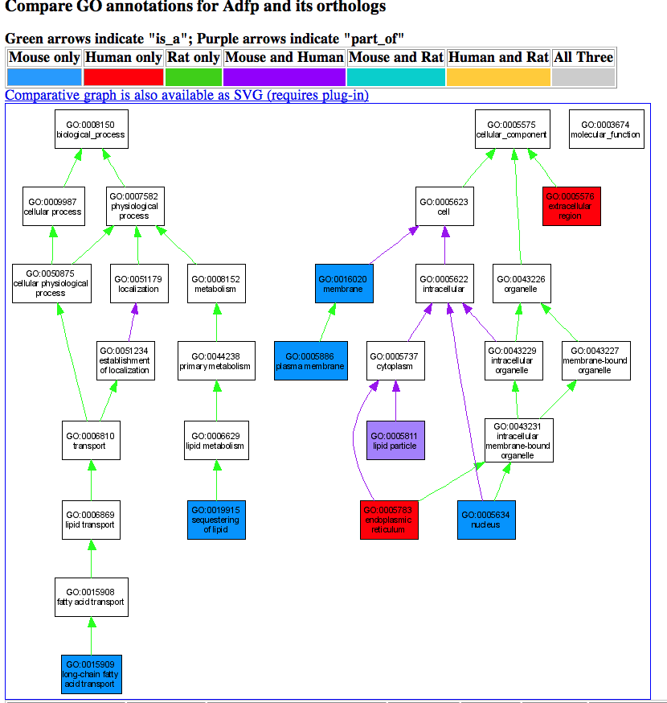

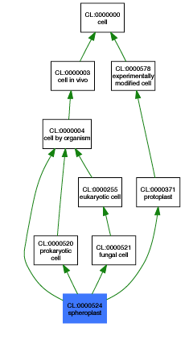

Figure 2. Portion of cell type ontology. (--->)

Figure 3: Portion of component ontology. (below)

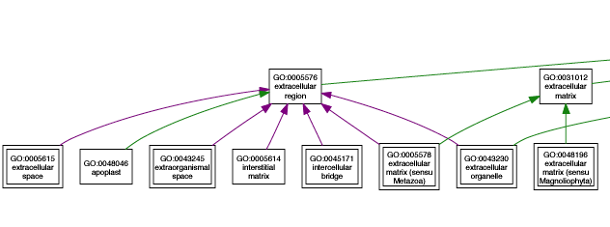

Number of genes with at least ONE GO term of any kind.

