TAIR GO report (January 16, 2004)

- GO staff: Suparna Mundodi
Tanya Berardini
Sue Rhee

- Annotation Progress:

Table 1: Number of annotations to various GO aspects.

 | Non-IEA evidence code | % difference | All evidence codes | % difference
Process | 3560 | 82 % | 18937 | 158%
Component | 2479 | 34% | 19380 | 114%
Function | 5966 | 10% | 24344 | 74%

Table 2: Number of genes annotated to various GO aspects

 | Non-IEA codes | % difference | All codes | % difference
genes annotated to process | 2637 | 45% | 12,423 | 62%
genes annotated to component | 2277 | 30% | 16,035 | 13%
genes annotated to function | 5511 | 3% | 15,187 | 58%

* Total number of genes annotated to at least one aspect of GO=19,422 out of ~30,000 genes in the genome.

- Ontology Development:
Added ~25 process terms, 9 function and 3 component terms, which are mostly plant specific.

- Publications: Working draft on ‘Functional annotation of the Arabidopsis genome’ in preparation and will be submitted January 30, 2004 for ‘Plant Physiology special issue’ to appear in June 2004.

6. Other highlights:
* Updated the IEA annotations based on Interpro release 09/24/03.

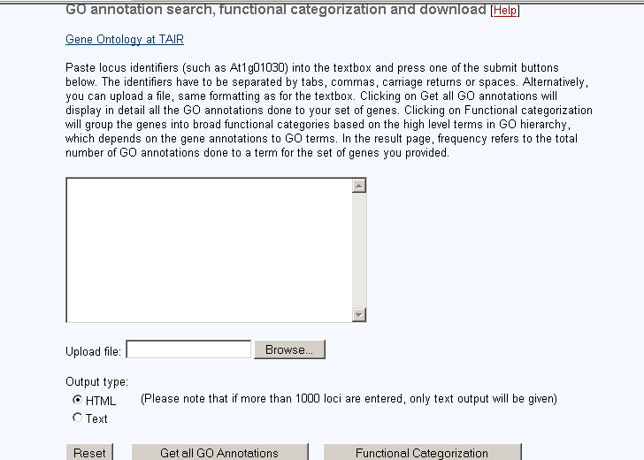
- User Interface:
Functional categorization
Initial Query page

Old New

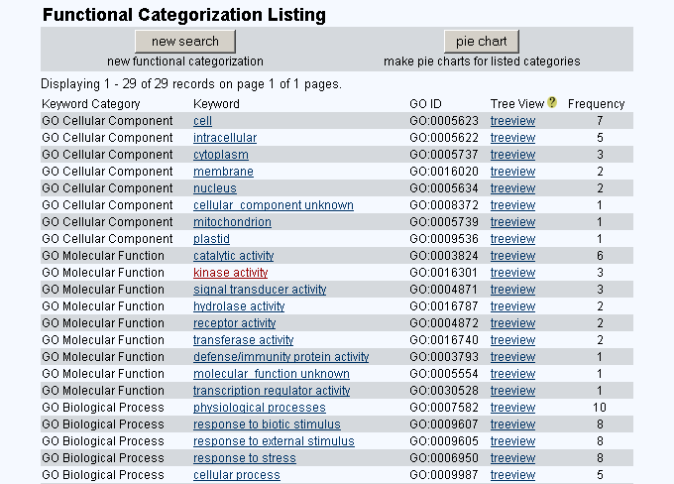
Functional categorization
result page

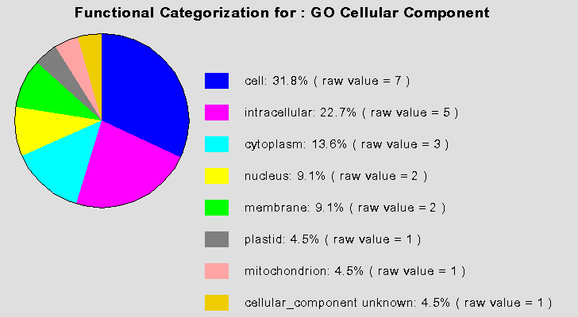
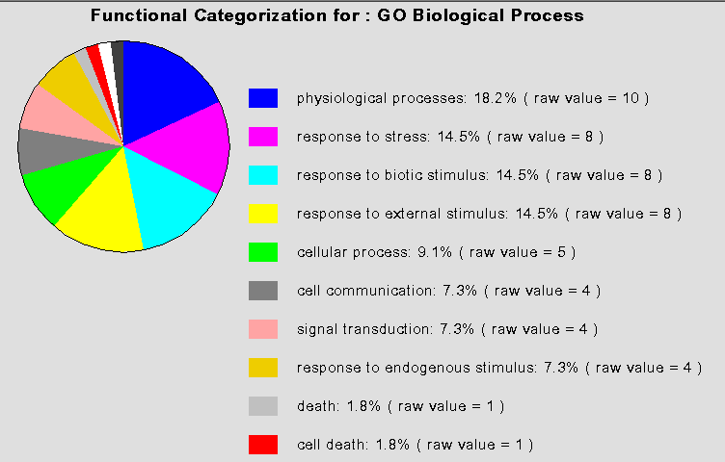
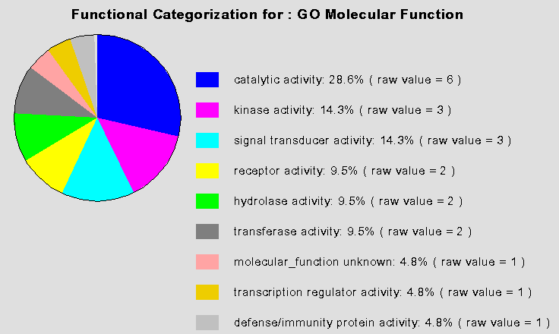

World of pies!!!

