General:

1.With the Fantom II load, collaboration with SWISS-PROT, and continued literature curation XX % of mouse genes now have at least IEA annotation. There are 3X,XXX mouse genes represented in the MGI system, and the majority of new literature coming in appears to be associated with a good portion of these, so we don't expect further large increases in the number of genes annotated to the GO. We continue our efforts at hand annotation for genes currently without GO annotation, and we continue to add further annotations the other genes, paying particular attention to genes with only IEA annotations.

MGI GO STATS as of May, 2003.

Annotation Type | 23-May_03 | 22-Sept_03 | Change | % Change
Total Genes annotated: | 12325 | 12682 | 357 | 2.9
Total Hand Annotation
Number of Genes | 3993 | 4497 | 504 | 12.6
Orthology: | 32 | 32 | 0 | 0
“IEA”
SwissProt to GO | 6916 | 7192 | 276 | 4.0
Interpro to GO | 3969 | 4238 | 269 | 6.8
EC to GO | 651 | 651 | 0 | 0
MLC Scan | 40 | 40 | 0 | 0
GO Fish | 2174 | 2152 | -22 | -1.0

2. We have added a new GO curator, Dr. Alexander Diehl. Alex is an immunologist who previously worked with the DeCode project in Iceland. (check this statement with Alex).

3. David and others have been working on improvements to the physiology branch of the process ontology. (see report from the Physiology IG)

4. Harold has been helping Karen Christie with parts of the RNA processing branches

Software:

1. Mary Dolan continues to work on implementing the GOTermFinder at MGI.
The current working model is at http://www.spatial.maine.edu/~mdolan/MGI_Term_Finder.html

Waiting for Mary to send me something

2. Joel Richardson has been working on a graphical veiwer for looking at GO annotations in MGI. The user inputs single or multiple gene symbols or ids from GenBank, SwissProt, EnSEMBL as well as MGI#s into a query box. The viewer returns both the number of identifiers/symbols entered and the actual number of MGI genes they resolved to as a graphical map of the terms annotated to these genes. The genes and annotation edges are NOT displayed since more than a few annotations makes the graph unreadable. However, it is relatively easy to get a sense of the extent of annotations that two or more genes have in common. Nodes may be “collapsed” if its score is not strictly greater than all its children's scores, even if it exceeds a threshold value (user selectable). A node having at least one direct annotation among the genes has a “*” added to its label. This is also shown on collapsed nodes. A "pruning" toggle can eliminate many of the collapsed nodes for ease of viewing. Joel will present a more detailed overview.

http://devwww.informatics.jax.org/~jer/wi/searches/AV2.cgi
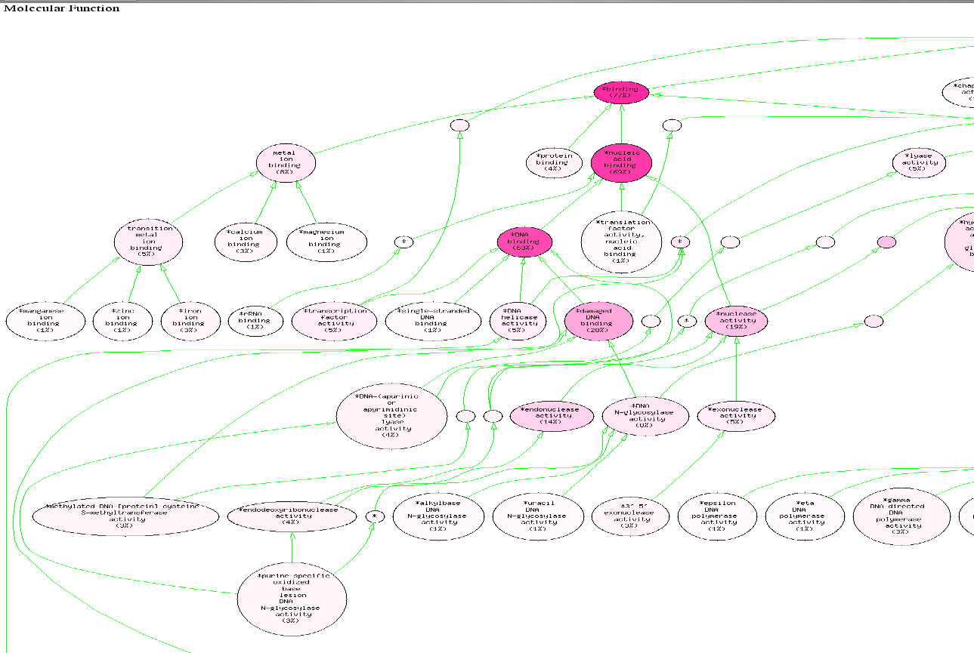

Number of genes with at least ONE GO term of any kind.
This figure has decreased due to our ongoing efforts to replace these with literature-based annotation.

