A Tutorial on Gene Ontology Resources

October 23, 2007

Judith Blake, Ph.D

Exploring GO Resources

The Gene Ontology is a controlled vocabulary of terms to describe gene product characteristics in the domains of localization and function. Databases using GO terms to annotate their genes and gene products can submit their annotations to the GO consortium where they are made freely available for other users to download and utilize. In this tutorial, you will learn how to download ontologies and annotations and how to browse and search the GO and its annotations.

Downloading the ontologies and annotations

If you want to incorporate GO ontologies or annotations in your computation work, you may need to download them. However you use the GO, it is important to understand how the ontologies and annotation files are structured and updated.

Go to the GO site: www.geneontology.org

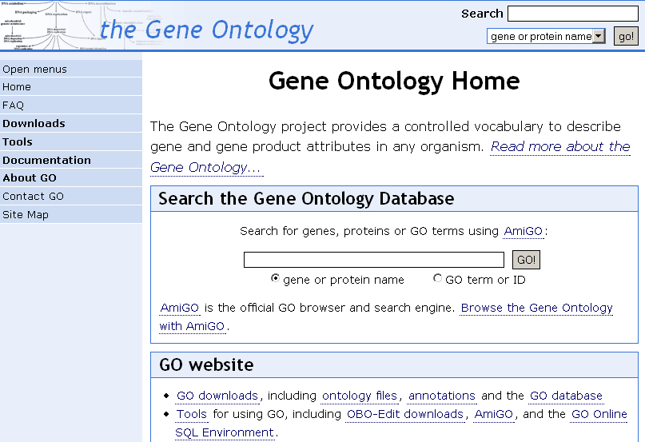
Open the menus for navigation (click on ‘Open Menus)

We will focus on three elements
- the current ontologies;
- the current annotations;
- documentation.

***It is important to distinguish the ontologies, which have been developed as organism-independent structured vocabularies, from the annotations, which are organism-specific and describe the organism’s gene product molecular function, biological process and cellular component using the GO. In some sense, the GO provides the tree on which biologists can hang their organism’s gene products.

The Current Ontologies are available at:
http://www.geneontology.org/GO.downloads.shtml

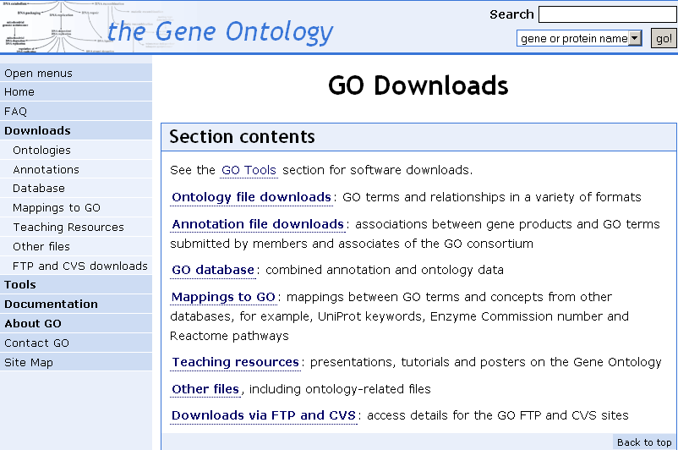

The three gene ontologies (Molecular Function; Biological Process, Cellular Component) can be downloaded by a user in different formats but all formats contain the same information: OBO text file ; XML; mySQL database.

If you click on Ontology file downloads, you will see that

as of October 23, 2007 at 18:00 Pacific time:
23901 terms, 97.7% with definitions.
13978 biological_process
2034 cellular_component
7889 molecular_function
There are 1130 obsolete terms not included in the above statistics. These terms have been obsoleted with because the term didn’t truly represent a type of function, process or component, or the term definition was incorrect.
Open the format guide if you want more information about the structure of the files. Note that these files are updated many times each day, on the average of every 30 minutes, as new terms and relationships are added by the GO curators. Some resources such as the NCBI and MGI refresh the GO files in their systems daily. Other resources don’t refresh their GO files as often. If you download or use the GO outside the GOC system, it is very important to check how old the files and data and annotations are that you are using.

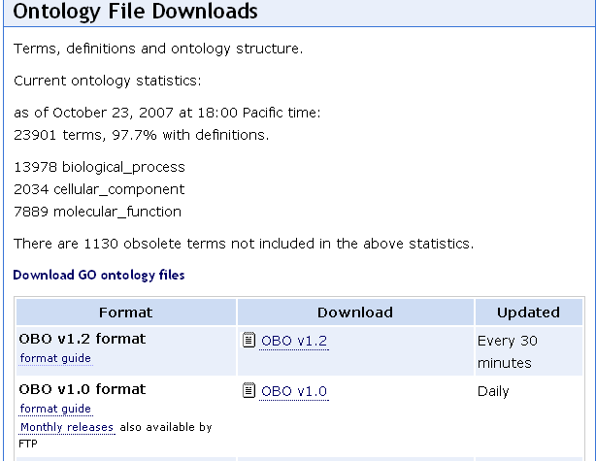

Try opening the ontology file “OBO v1.2’

Note the flat-file format:
format-version: 1.2
date: 22:10:2007 15:54
saved-by: Tanya Berardini
auto-generated-by: OBO-Edit 1.101
subsetdef: goslim_candida "Candida GO slim"
subsetdef: goslim_generic "Generic GO slim"
subsetdef: goslim_goa "GOA and proteome slim"
subsetdef: goslim_pir "PIR GO slim"
subsetdef: goslim_plant "Plant GO slim"
subsetdef: goslim_yeast "Yeast GO slim"
subsetdef: gosubset_prok "Prokaryotic GO subset"
default-namespace: gene_ontology
remark: cvs version: $Revision: 5.521 $

[Term]
id: GO:0000001
name: mitochondrion inheritance
namespace: biological_process
def: "The distribution of mitochondria, including the mitochondrial genome, into daughter cells after mitosis or meiosis, mediated by interactions between mitochondria and the cytoskeleton." [GOC:mcc, PMID:10873824, PMID:11389764]
synonym: "mitochondrial inheritance" EXACT []
is_a: GO:0048308 ! organelle inheritance
is_a: GO:0048311 ! mitochondrion distribution

[Term]
id: GO:0000002
name: mitochondrial genome maintenance
namespace: biological_process
def: "The maintenance of the structure and integrity of the mitochondrial genome." [GOC:ai]
is_a: GO:0007005 ! mitochondrion organization and biogenesis

After some version information, there is a stanza of information about each term. The definition is tied to the id. Notice that each definition is followed by [ ] in which the source of the definition is provided. For example, for the term ‘mitochondrion inheritance’, the [GOC:mcc, PMID:10873824, PMID:11389764] represents that the terms was provided the GOC member ‘mcc’, and that the reference PMID:10873824, PMID:11389764 was the source the curator used.

A tool that is used to explore the structure of the GO is the GO Browser, for example, AmiGO: http://www.godatabase.org/cgi-bin/go.cgi
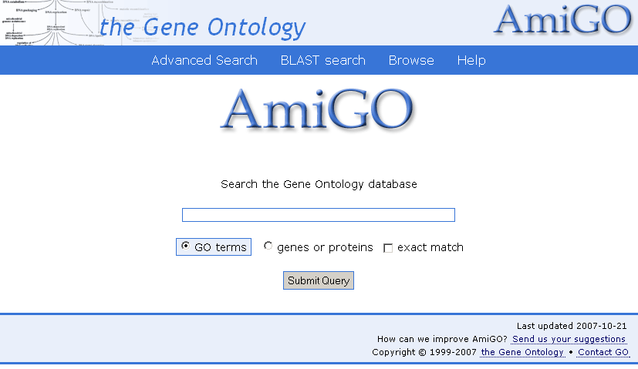

AmiGO is an HTML-based browser which enables browsing and searching of both the gene ontologies and the gene associations. Each GO term gets one horizontal line.

Enter the term ‘carbohydrate metabolism’ and ‘submit query’.

The query results will show all the terms that include the string ‘carbohydrate metabolism’. Click on the first term ‘carbohydrate biosynthetic process’

The first thing on each line can be either a , or a icon. can be used to expand a node, showing all the children of the selected term. can be used to deselect a term, closing the node. Finally, means that the term on that line has no children. The next thing on each line can be either a or icon, which represent, respectively, a part_of or is_a relationship. Following each term is a number in parentheses. This tells the total number of gene products that have been annotated to this term or to a more specific term below this in the GO tree.

We will do more with GO browsers later in the tutorial.

The Current Annotations are available at: http://www.geneontology.org/GO.current.annotations.shtml

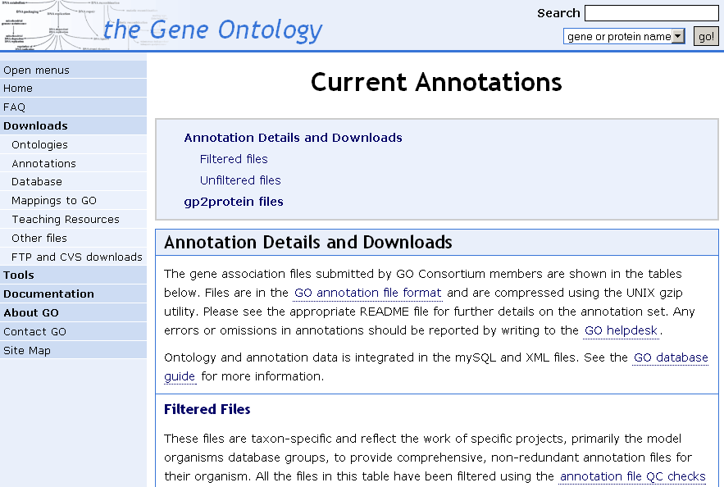

The current annotations for many organisms are available here for download to use in conjunction with the ontologies. The structures of the annotation files can be seen in an example here http://www.geneontology.org/GO.annotation.fields.shtml

Click on ‘Annotation Files and Downloads’ [see arrow in screen shot]to look at files available for the model organism genomes.

Notice that the total gene products associated values vary significantly from organism to organism. For example, SGD Saccharomyces cerevisiae (yeast) shows 6476 total genes associated with GO terms; MGI Mus musculus (mouse) shows 18086;

How many genes in the ZFIN (zebrafish) database are associated with GO terms?

These differences reflect both the differences in the number of genes in each organism and the state of annotation. The yeast genome has been essentially completely annotated to GO; the mouse genome is very well annotated for many of its approximately 30,000 genes; the GO annotation work on the zebrafish is in its beginning stages.

Now open the README file for the Mus musculus (mouse) annotation file. This give you information about the zipped geneassociatons.file. If you were to download the associations file to your desktop and upzip it, it would look like the figues below.

Shown here is a part of the tab-delimited MGI annotations file. The first line shows that the gene product of the gene with MGI accession number MGI:1915562 has been annotated to the molecular function ontology (F) term “transferase activity” with GO id GO:0016740.

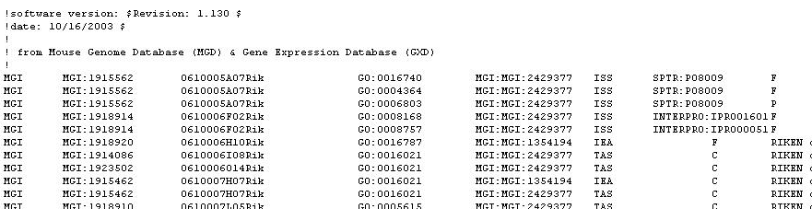

An introduction to Gene Ontology documentation can be found at http://www.geneontology.org/GO.contents.doc.shtml

You can find this link in the left menu bar as well.

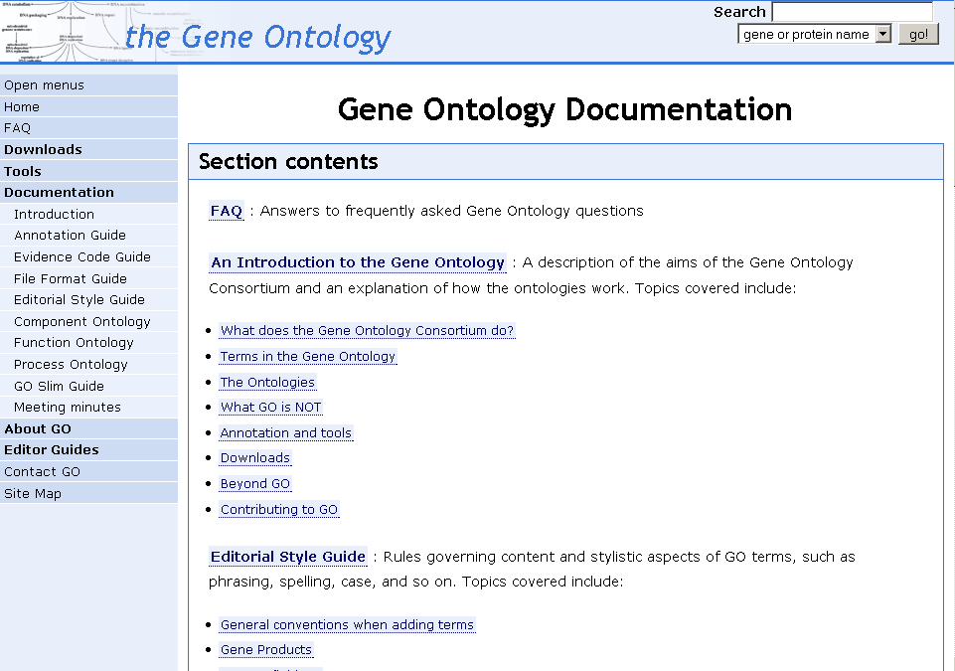

Browsing and searching GO and its annotations

This part of the tutorial will show you how to browse and search the Gene Ontology and the annotations made using its terms.

The first part of this tutorial uses the AmiGO Browser (http://www.godatabase.org/), developed by the Gene Ontology Consortium, but there are also many other GO browsers (see http://www.geneontology.org/GO.tools.html) developed by outside groups that can be used.

Open AmiGO at http://www.godatabase.org/ ; in the top toolbar, click on ‘Browse’

You will see the Gene Ontology graph with the three ontologies: biological process, cellular component and molecular function, as well as the three nodes of obsolete terms, containing terms that have been removed from the active ontologies.

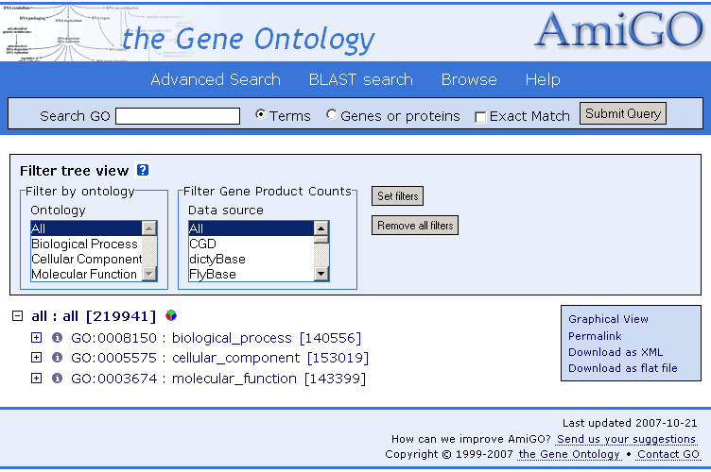

You can navigate the tree by clicking on the + and – icons at the start of each line.
+ expands a node, showing all the children of the term.
– closes the node, hiding the children.
- means that the term on that line has no children.

Grayed out terms are obsolete, meaning that they are deprecated and should no longer be used.

Each term gets one horizontal line.

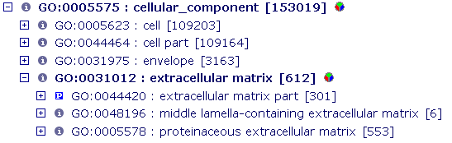

The and icons represent the relationship of the term to its parent, either "is a" and "part of" the parent term.

The GO term identifier and term name can be clicked to get a more detailed view of the term, including the definition and all genes and gene products annotated to the term.

Following the term ID and name is a number in parentheses. This is the total number of genes manually annotated to this term and its children. Electronic annotations (evidence code IEA) are not shown for two reasons: there are large numbers of these annotations, and they are deemed lower quality as they have not been checked by a human.

Terms may be followed by the icon. Clicking this icon will bring you to a pie chart which displays the percentage of gene products annotated to each term below that selected. Clicking on a term itself will also give you the pie chart.

Open the nodes biological process -> metabolic process -> catabolic process

How many annotations does catabolic process have to it?

Does this number include IEA annotations?

Click on catabolic process. What relationship does regulation of catabolic process have to its parent catabolic process?

Clicking on a term name or ID opens the term detail page.

Click on ‘regulation of catabolic process’

The term detail page shows all the information available about the term: the term name and ID, any synonyms it might have, the term definition, its position in the GO structure, references to external databases, and the gene products associated with that term. Note that children of the selected term are not shown.

You can click on "Graphical view" for an alternate representation of the tree structure.

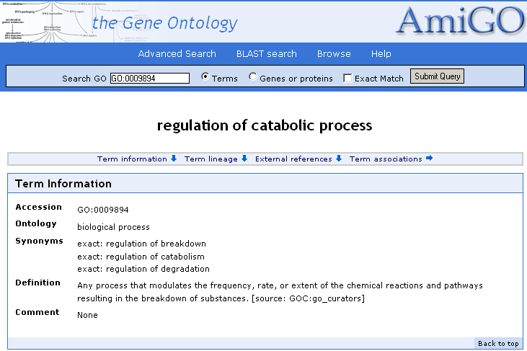
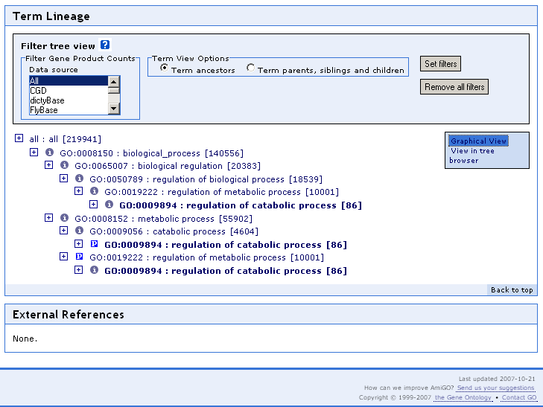

Using the ‘search box’ at the upper left, and search on the term cytokine secretion. It will open in a new window.

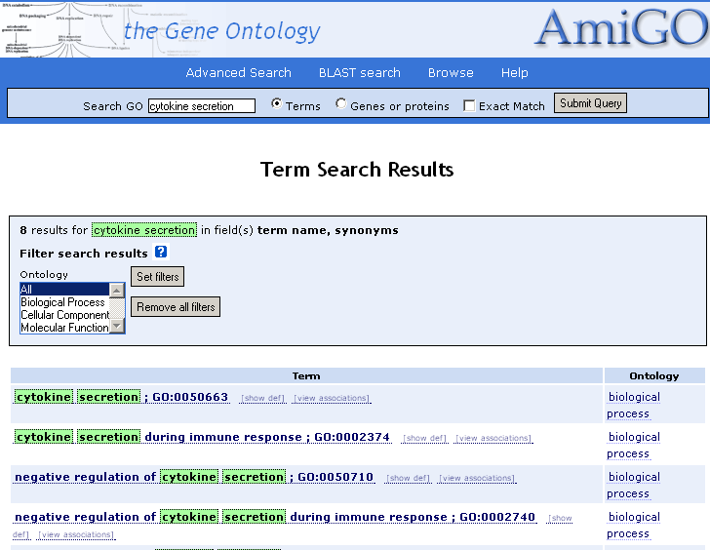

Now click the top term ‘cytokine secretion to open the term lineage; that is, all the terms above it in the tree are shown in this view.

What are the parents of cytokine secretion and what are the relationships between cytokine secretion and its parents?

For more info on the contributing databases see the Gene Ontology website indices to other classification systems (http://www.geneontology.org/GO.indices.html) and acknowledgements page (http://www.geneontology.org/GO.a.html).

Now click on the number next to the term ‘cytokine secretion’; in this case, on the [42]. A new page will open. Beneath the term information are the annotations, the genes or gene products assigned the selected term.

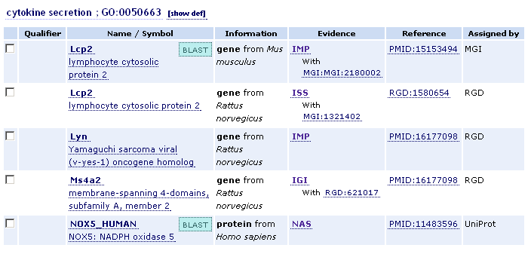

The first column is the gene or gene product symbol and name; clicking on the name will take you to the AmiGO gene product detail page, which shows the information held in the GO database about that gene product, including all its GO annotations and the peptide sequence (if available). By clicking on the left box and creating a check for the gene, you can then forward the FASTA protein sequence stored in the database to a BLAST search. We will do this at the end of this tutorial.

The second column is the data source that submitted the annotation (e.g. FlyBase, SGD, UniProt), and clicking on this takes you to the detail page at the source's website. The bolded term, such as ‘gene’ , indicates the entity (real thing) that is being annotated (associated with a GO term).

The third column is the evidence code for the association; when underlined, clicking on the evidence code brings up the source reference used to make the association.

The fourth column links to the biomedical literature from which the annotation was curated. In the case of PubMed IDs, this will link to PubMedCentral.

The final column has the name of the GOC resource group that generated this annotation.

You can choose to view the annotations to the term itself or to the term and its children.

Go back to the cytokine secretion term detail page. From the drop-down menu on the right, choose get "All associations with terms" and click submit.

How many gene products are annotated directly to cytokine secretion?

Note the filtering menus in the light grey box. You can also choose to filter annotations by the database that supplied them, by the evidence code used in the annotation and by species.

Choose ‘MGI’ from the ‘datasource’ menu and click the ‘Submit Query’ button.

MGI stands for ‘Mouse Genome Informatics’, which is the M. musculus genome database. By filtering on this datasource, only gene associations from MGI i.e. all mouse are displayed in the gene list. This also works on the main page by using the filter boxes on the left of the interface.

Shut the popup window and return to the main page.

Searching with AmiGO

We have already used the search box to search by a GO term. Now we will search AmiGO using a gene product name

At the top of the page there is a search box. GO terms or associated gene products can be searched by checking the "terms" or "gene products" boxes respectively.

Perform a search for gene products containing the text 'grim'.

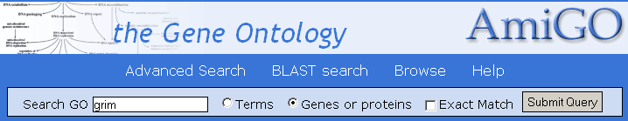

The results list displays all gene products containing the text "grim", and the name of the external database which the gene product is from.

Why is the gene Ndufa13 returned by the search with the gene symbol / name ‘grim’ ?

Click on the first gene ‘grim’ from the Drosophila melanogaster database. Scroll down the page to see all the gene products that are returned by this search.

Notice that one of the rows of annotaton reads ‘not’ nurse cell apoptosis. This means that the reference cited provides experimental information that the ‘grim’ gene is explicitly not involved in this process. This information is reported by scientists and reflected in the annotation when a gene product is expected to be in involved in a particular function or process, but is shown not to be. The expectation may arise from overall sequence similarity to other genes that do have a particular function are or involved in a particular process.

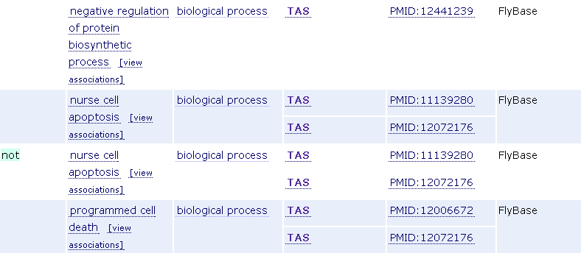

Perform another search by gene product name. This time search for the FlyBase gene product name ‘Buffy’

How many GO terms is the FlyBase gene product "Buffy" associated with?

Do a search for your favorite gene product.

What gene did you search on?
Did you find this gene represented in AmiGO?
How many GO terms have been used to annotated this gene?
Does this gene need additional functional annotation in the GO system?

If your favorite gene product is missing critical information that you are aware of, you can contact the GO with suggestions for annotation. Go to the top menu bar in AmiGO and select the ‘Help’ button. Down the left menu of the Help page, click on ‘HelpDesk’. Here you can contribute to the GO by sending in information about your favorite gene. Be sure to include:

Gene ID [from MOD, EntrezGene or UnitProt]
Gene Symbol or Name
Publication [PubMed ID] with experimental data
Suggestions [GO:ID and/or GO term] for GO annotation

Thank you.

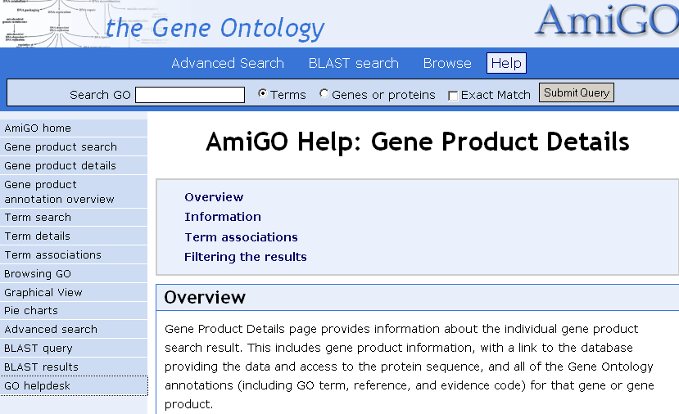

Pie Charts

Return to the AmiGO main page (http://www.godatabase.org) and expand the term biological process to view its children. Choose ‘MGI’ from the ‘datasource’ menu on the left-hand side and click ‘Submit Query’. Now click the pie icon that now appears next to biological process.

This displays the annotation totals from MGI (mouse) as a pie-chart. The terms included in the chart can be changed by expanding and collapsing nodes.

BLAST in GOdb =GOst

GOst is the Gene Ontology BLAST server, which allows you to blast a protein sequence against all gene products that have a GO annotation. All the groups that contribute GO annotations to the AmiGO database also contribute a protein identifier for the gene product. This is used to create BLASTable database integrated with the GO annotations.

Return to the main AmiGO page and click "BLAST" (at the top of the page). Enter the UniProt accession number Q61337 into the top box and click submit.

This performs a Blast search of the protein sequence of Q61337 against the GO database, and returns the top hits, with their GO annotations.

What is the top hit? What GO terms are associated with them?

Thank you for completing this GO tutorial using the AmiGO database. We hope you have found this useful. Please send suggestions and comments to the GOhelp Desk. We need your help as much as we hope we can help you. Cheers.

