Does your species show in GO?
Annotating to the Gene Ontology (GO):
The Gene Ontology Consortium is a collaborative effort between several model organism databases as well as other databases to develop a common terminology for describing genes and gene products.
The goal: Make searching across databases (that describe their genes using a wide variety of terminologies mostly dictated by their community), easier and thus information searching and retrieval by a computer easier. Genes are annotated to terms from three ontologies that help to describe the gene in terms of it’s molecular function, what biological processes it affects and the cellular component in which it acts.

Reference:
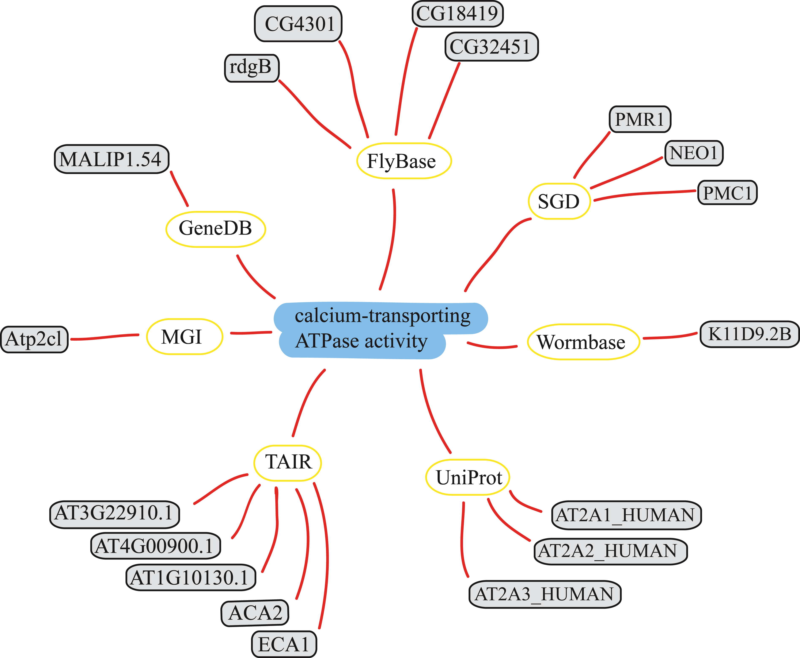

Annotate genes/gene products and send your data to the GO consortium…

1. Which process is it involved in?
2. What is it’s function?
3. What cellular component does it act in?
4. Provide a published paper as a reference
5. What kind of evidence is provided in the published paper to support the above…experimental? Expression studies? Just an author statement?

What format should the data be in?
Ideally it should be in a ‘gene association’ file format, but it could be just a spread-sheet to begin with.
Example of a GO annotation:
Annotation of daf-16 (HNF-3/forkhead family) in WormBase:
(Note: Annotations shown without evidence codes and references)

Biological Process:
dauer larval development
determination of adult life span
regulation of transcription, DNA- dependent
response to heat

Cellular Component:
cytoplasm
nucleus

Molecular Function:
sequence specific DNA binding
transcription factor activity

Join those already annotating to the GO…
WormBase, FlyBase, BDGP, TAIR, TIGR, GOA@EBI, GeneDB, DictyBase, RGD, MGD, SGD, ZFIN, Gramene and others.
Contact information:
GO consortium website: http://www.geneontology.org
GO consortium e-mail: go@genome.stanford.edu
GO paper reference: Gene Ontology: tool for the unification of biology. The Gene Ontology Consortium (2000) Nature Genet. 25: 25-29

WormBase website: http://www.wormbase.org
WormBase GO curators: go@wormbase.org

