Rat Genome Database - December, 2007

Overview:

1. Staff:
Project Management
- Simon Twigger, PI (0.05 FTE funded by GOC grant)
- Mary Shimoyama

GO Curators:
- Victoria Petri (0.8 FTE funded by GOC grant)
- Stan Laulederkind
- Jennifer Smith

IT staff associated with GO related projects such as the development of the online curation tool and of pipelines, the updates/loads of GO ontologies in the database and the generation and submission of RGD Gene Association files.
- George Kowalski
- Jeff dePons
- Alex Stoddard
None of the IT staff are funded by the GOC grant

2. Annotation Progress
Based on the association file at the GO site dated November 3, 2007, there are 31,301 gene products with annotations. From 2006, this represents a 166% increase in the number of annotated genes. There are 183,028 annotations, of which 79,739 are non-IEA. In 2006, there were 82,432 annotations of which 27,792 were non-IEA annotations. This represents a 122% and a 187% increase in the number of total and of non-IEA annotations, respectively (also Table below). Total numbers represent manual annotations done at RGD, manual annotations of rat genes done by other groups (mostly GOA, but also MGI), electronic annotations based on InterPro, Enzyme Commission or SwissProt keywords mapping to GO, GO annotations of human and mouse genes electronically brought in as ISS with previous pipelines. We are now in the process of revamping these pipelines to assure that GO annotations using evidence codes other than the experimental ones are not loaded into the database.

Total annotations non-IEA annotations Genes with annotations
183,028 | 79,739 | 31,301
122% increase | 187% increase | 166% increase

The RGD GO curation software tool can generate various yearly reports. Based on these reports we show that:
- from January to present (November 2007) the number of manually generated GO annotations increased from 8,047 to 16,120 representing a 100% increase in the number of annotations for the ten and half months of 2007.

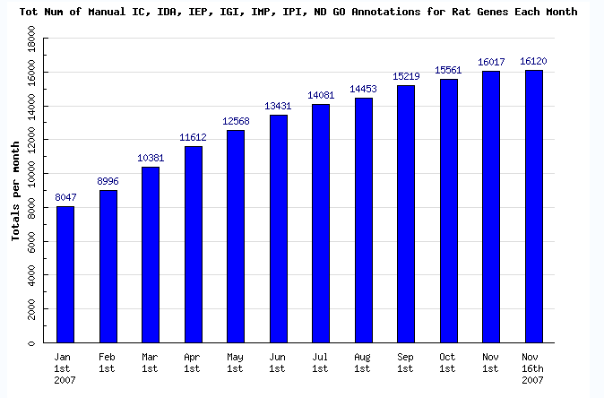

The number of genes with manual GO annotations has increased from 2,258 to 3,945 representing a 75% increase during this time period.

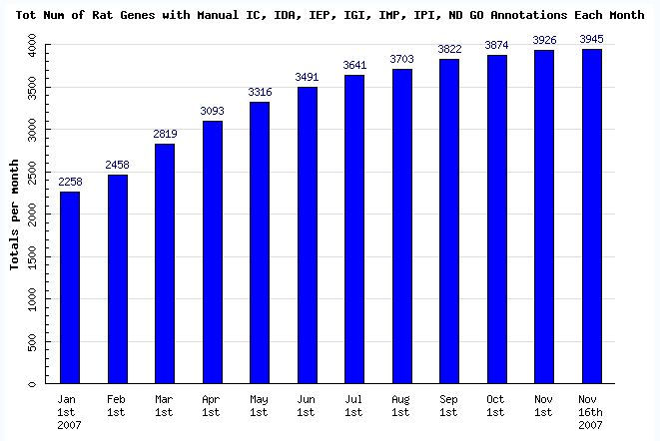

3. Methods and strategies for annotation
(please note % effort on literature curation vs. computational annotation methods)
Because the pipelines for GO annotations are automated and updated weekly, all of the curators’ efforts are involved in manual annotation. Although RGD curators also annotate to other ontologies, approximately 75% of their curation efforts are related to GO annotations
- Literature curation:
RGD targets gene sets for manual curation and all rat papers published about those genes are curated. In 2007, there have been 3 major types of gene datasets 1) disease related: cardiovascular, obesity and metabolic syndrome genes; 2) genes which are part of the GO Reference Genomes project, and 3) genes involved in pathways associated with the disease datasets.

Computational annotation strategies:
A). Rat genes manually curated by other groups are brought in electronically from GOA with their associated evidence codes and the originating group acknowledged in the source.
B). ISS - RGD is not currently doing manual annotation with ISS. ISS annotations have been brought in from MGD and GOA in the past. The pipelines for these are in the process of being redesigned to allow weekly updates, filter out redundancies and inappropriate associations
C). IEA - rat annotations based on GO mapping to InterPro, Enzyme Commission and Swiss-Prot keywords, are brought in electronically with IEA evidence code from GOA. Annotations from GOA for all categories are updated weekly.
Priorities for annotation
There are several ways in which RGD assigns priorities for the annotation of genes to GO ontology terms. These include: the genes in the monthly list for the Reference Genomes project, genes associated with targeted disease, and genes involved in particular pathways.

4. Presentations and Publications
a. Papers with substantial GO content

Nothing to report.

b. Presentations including Talks and Tutorials and Teaching
- At the International Mammalian Genome Society Meeting held in Kyoto, Japan in the fall of 2007, RGD presented the Disease Portals project. Ontology annotations with an emphasis on GO is a major priority at RGD. The portal view always displays the GO Charts with the overview of GO annotations for the three vocabularies.
- Simon Twigger gave a lecture on the GO and ontologies as part of the joint MCW/Marquette University Bioinformatics Masters Program.
- Simon Twigger gave lectures at the Institute for Systems Biology (Seattle, WA. January 2007) and the University of Kentucky (Lexington, KY. February 2007) describing RGD, GO and the GOC and how RGD uses GO in the processes of genome annotation.
- Simon Twigger gave a presentation entitled “RGD and the Gene Ontology - Building and using biomedical ontologies for translational research” at the NHLBI HLB_STAT! data standards workshop held at NIH in May, 2007. This described the GO and how it was being used at RGD and other MODs in the annotation of gene products and also talked about the GOC and the process of ontology development.

c. Poster presentations
- The poster presented at the Human Genome Meeting in Montreal in May 2007 covered the Disease Portals project.
- Posters presented at the Biology of Genomes Meeting at Cold Spring Harbor in the spring of 2007 dealt with biological information at RGD and with the Disease Portals project.
- Posters presented at the First International Midwest Symposium on Computational Biology and Bioinformatics held at Northwestern University in the fall of 2007, covered the portals, the pipelines (one other way we increase the number of GO annotations at RGD), tools such as the online curation software that has dramatically improved the annotation process.
- Posters presented at the Second International Biocuration Meeting at San Jose in October 2007 dealt with the Disease Portals and the pipelines projects.

5. Other Highlights:

A. Ontology Development Contributions:
RGD has hosted several webex meetings and a one and a half day workshop for the improvement of the GO process ontology part dealing with the regulation of blood pressure. The meetings were attended by members of RGD, the GOC and experts in the field. These experts included two members of the MCW Department of Physiology (Dr Mingyu Liang and Dr Diane Munzenmaier) and Dr Keith DiPetrillo from Novartis. The improved GO process ontology has recently been released and this is reported in the November issue of the GOC Newsletter.

B. Annotation Outreach and User Advocacy Efforts:
Nothing to report.

C. Other Highlights:
Nothing to report.

