Mouse Genome Informatics (MGI) - Progress Report
Gene Ontology Consortium Meeting, CalTech. April 8th – 9th, 2005.

1. Staff:
Curators: Alexander Diehl, Harold Drabkin, David Hill, Li Ni,
Analyst: Mary Dolan
Summer Students: Christopher Hollenbeck and Megan Campbell.

2. Annotation Progress
We continue our efforts at hand annotation for genes currently without GO annotation (Li, David), and we continue to add further annotations the other genes, paying particular attention to genes with only IEA. We currently have over 16,250 genes with some annotation (95574 annotations). Due to continued aggressive annotation strategies, we continue to increase our hand annotation by 25%. In fact, we currently now have only about 4500 genes that have “IEA only” annotation.

MGI GO STATS as of March 10, 2005

Annotation Type | 24_Mar_05 | 04-Oct_04 | Change | % Change
Total Genes annotated: | 16145 | 15304 | 841 | 5.5
Total Hand Annotation
Number of Genes | 7914 | 6248 | 1666 | 26.7
Orthology: | 308 | 223 | 85 | 38.1
“IEA”
SwissProt to GO | 11096 | 9575 | 1521 | 15.9
Interpro to GO | 5643 | 5178 | 465 | 9.0
EC to GO | 650 | 650 | 0 | 0
MLC Scan | 0 | 40 | 0 | 0
GO Fish | 1984 | 2065 | --81 | -3.9

Annotation Methods:

Annotation Strategies:
To aid in manual curation efforts, various QC reports are generated daily. These include:

Genes with no GO Associations (also broken down into those with literature references associated with them or those with no literature references associated with them (Data loads).
Genes with references that are selected for GO but have not been used. These are further broken down into whether or not the genes have any GO associations.
Genes with GO Associations of evidence IEA only. These are further broken down according to whether or not they literature or those from data loads only.
Genes with Annotation to IMP, but the “Inferred From” field is empty, but there are reference associations to alleles
All genes with 'unknown' annotations with new indexed literature
Mouse Genes that have Rat Homologs but no GO associations

Consistency between Mouse, Human, and Rat annotation
Mary Dolan has been analyzing the consistency of non-IEA annotations using mouse-human-rat GO annotations in the context of MGI curated orthology. Based on GO_Slim categorization, the consistency of the annotations is assessed: matches, mismatches and missing annotation for every mouse-human and mouse-rat orthologous gene pair are reported. Monthly reports are generated and posted on our website, including a report of changes from the previous month to facilitate curator review.

As a complement to our GO annotation consistency reports, we are generating GO comparative graphs as shown here for mouse gene Oxt2 and its human ortholog OXT2. These subgraphs of the full molecular function ontology show all direct GO annotations.
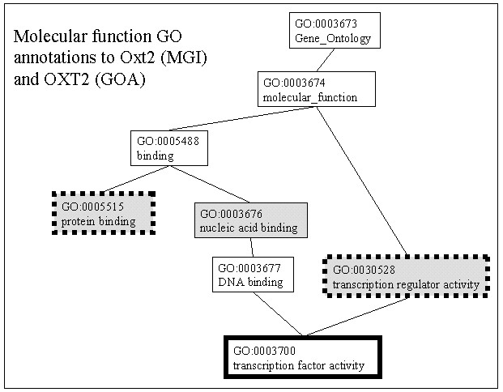
Rectangles outlined in solid line are GOA annotations; dotted lines indicate MGI annotations. The shaded rectangles correspond to GO nodes that define GO_Slim categories, unshaded rectangles show additional nodes in the GO structure. In this way, curators reviewing the GO annotation consistency report can immediately see the source of mismatches (potential inconsistencies) and, additionally, review granularity differences for matches (assumed consistencies).

4. Publications:
Drabkin HJ, Hollenbeck C, Hill DP, Blake JA. Ontological visualization of protein-protein interactions. BMC Bioinformatics. 2005 Feb 11;6(1):29.

5. Other Highlights

Developing human readable-text summaries of GO annotations
Chris , David, Alex, Mary, Harold
We have moved forward with the idea of generating narrative paragraphs generated from GO annotations. This provides a more reader-friendly summary of the information that we know about a gene to our small-scale users. The scripts generating the paragraphs are run on a (weekly, monthly) basis.

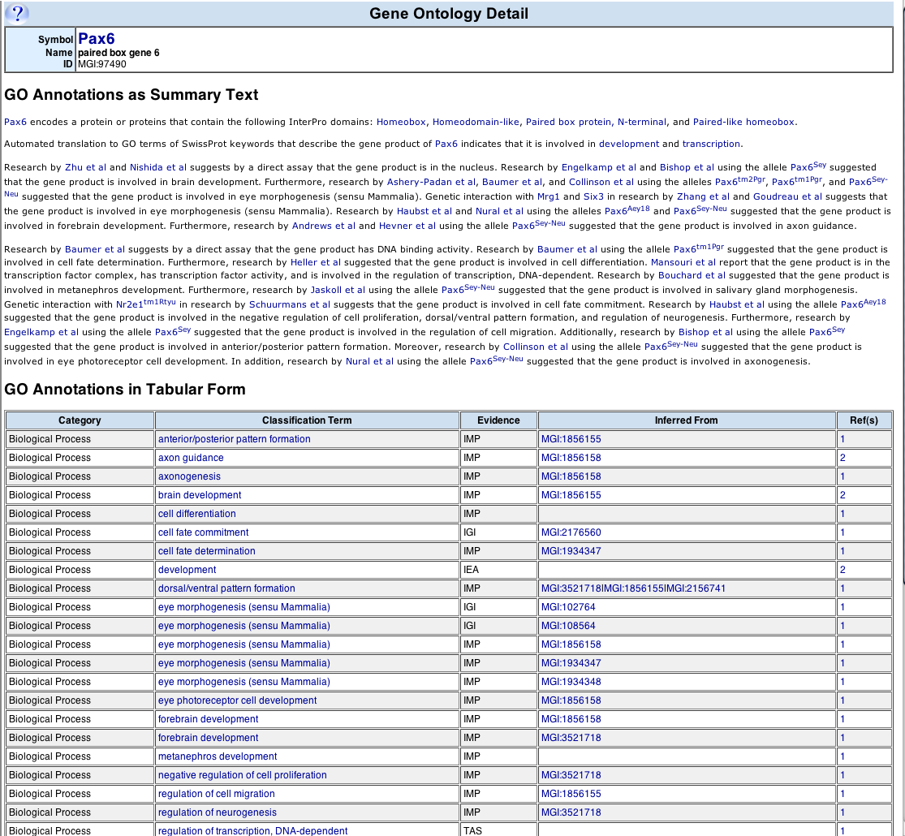

Outreach: Chicken DB

We have had Fiona McCarthy from the chicken genome database in Mississippi visit MGI to undergo intensive training on all aspects of the GO (annotation and development). Her goal is to annotation chicken proteins from an MPSS survey.

Number of genes with at least ONE GO term of any kind.
MGI is phasing out the Mouse Locus Catalog (MLC), a textual summary of functional and phenotypical, data, as the use of the GO, MP, and other controlled vocabularies increases. Therefore, we have removed and replaced GO data derived from scanning this summary. This is the last entry for this class.
This figure continues to decrease due to our ongoing efforts to replace these with literature-based annotation.

