TAIR GO report (October 2004)

- GO staff: Suparna Mundodi – annotation, ontology development
Tanya Berardini – annotation, ontology development
Sue Rhee – annotation, ontology development
Leonore Reiser – annotation
Marga Garcia-Hernandez – annotation
Peifen Zhang - annotation
Eva Huala – annotation

GO annotation constitutes about 50% of our genomic functional annotation project. TAIR has four other major projects: structural annotation, gene expression integration, outreach and education and pathway annotation.

- Annotation Progress:

Table 1: Number of annotations to various GO aspects.

GENES | Process |  |  | Function |  |  | Component
 | Jan. 2004 | Oct. 2004 | % change | Jan. 2004 | Oct. 2004 | % change | Jan. 2004 | Oct. 2004 | %change
IEA | 9514 | 9762 | 18.8 | 9159 | 9164 | 0.1 | 4933 | 14401 | 191.9
ND | 58 | 11300 | 19382.8 | 498 | 1456 | 192.4 | 1152 | 10634 | 823.1
non-IEA/non-ND | 2393 | 2910 | 21.6 | 4277 | 5103 | 19.3 | 1038 | 1280 | 23.3

*Large increases in process and component annotations result from many ND annotations being made for genes for which there is neither associated literature nor any computationally predicted function, process or component.

Table 2: Number of genes annotated to various GO aspects

ANNOTATIONS | Process |  |  | Function |  |  | Component
 | Jan. 2004 | Oct. 2004 | % change | Jan. 2004 | Oct. 2004 | % change | Jan. 2004 | Oct. 2004 | %change
IEA | 14616 | 15007 | 2.7 | 16959 | 16999 | 0.2 | 6481 | 17906 | 176.3
ND | 58 | 11300 | 19382.8 | 498 | 1456 | 192.4 | 1152 | 10634 | 823.1
non-IEA/non-ND | 3191 | 3984 | 24.9 | 4599 | 5809 | 26.3 | 1227 | 1541 | 25.6

- Method of annotation:
a. Literature curation - majority of effort centered here
b. Automatic or semi-automated methods – TargetP update

- Ontology Development:

a. Terms added: 11 process terms
b. Content meeting:
Suparna: pathogenesis, brought in plant pathogenesis experts for this discussion
Sue, Tanya, Peifen, Hartmut: metabolism discussion

c. DAG-Edit workshop: attended by Suparna Mundodi and Katica Ilic

- Publications:
Berardini TZ, Mundodi S, Reiser L, Huala E, Garcia-Hernandez M, Zhang P, Mueller LA, Yoon J, Doyle A, Lander G, Moseyko N, Yoo D, Xu I, Zoeckler B, Montoya M, Miller N, Weems D, Rhee SY. (2004) Functional annotation of the Arabidopsis genome using controlled vocabularies. Plant Physiol.Jun;135(2):745-55.

- Other highlights:
  - new GO slim lists generated for TAIR, 15 terms each
  - accepting user submitted functional annotations, annotations are attributed to the community member
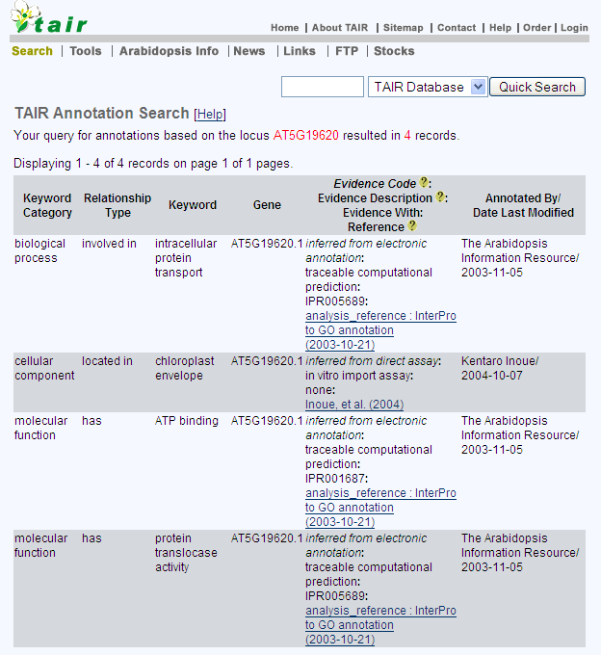

  - involving the community: post-doc trainees

