1. Staff:
Curators: Alexander Diehl, Harold Drabkin, David Hill, Li Ni,
Analyst: Mary Dolan,
PIs: Judith Blake, Janan Eppig, Jim Kadin, Joel Richardson, Martin Ringwald,
Summer Students: Christopher Hollenbeck and Megan Campbell.

2. Annotation Progress
We currently have over 15,300 genes with some annotation (80, 304 annotations). These numbers reflect a larger time period than previous meetings (9 months vs usually 4).

MGI GO STATS as of Oct. 4, 2004

Annotation Type | 6-Jan_04 | 04-Oct_04 | Change | % Change
Total Genes annotated: | 12761 | 15304 | 2543 | 19.9
Total Hand Annotation
Number of Genes | 4804 | 6248 | 1444 | 30.0
Orthology: | 33 | 223 | 190 | 575.6

“IEA”
SwissProt to GO | 7488 | 9575 | 2087 | 28.7
Interpro to GO | 4513 | 5178 | 665 | 14.7
EC to GO | 651 | 650 | 0 | 0
MLC Scan | 40 | 40 | 0 | 0
GO Fish | 2131 | 2065 | -66 | -3.1

3. Methods of Annotation

- Literature curation:
We continue our priority efforts at hand annotation for genes currently without any GO annotation (Li, Alex, Harold, David), and we continue to add further annotations to the other genes, paying particular attention to genes with only IEA. Additionally, we have been aggressively using MGI orthology sets to human and rat proteins where there is good experimental literature in the other species, Finally, the data generated by analysis of protein binding (GO:0005515( has flagged missing reciprocal annotations, which are being added.

- Computational Annotation: OLFRs
Bob Sincair has been working with Janet Young on a large-scale effort to characterize all of the olfactory receptors in the mouse genome. Using sequence comparisons, they have identified approximately 1500 genes that will receive GO anotations for function, process and component.

c. Consistency between Mouse, Human, and Rat annotation
Mary Dolan, with one of our summer interns Megan Campbell, has been analyzing the consistency of non-IEA annotations among the mammals. This is done using mouse-human-rat GO annotations in the context of curated orthology. For the complete set of mouse-human and mouse-rat orthologs as maintained by MGI, independent GO_Slim categorizations are calculated for the mouse genes using MGI annotations, for the human genes using GOA, and for rat genes using RGD. Based on this categorization, the consistency of the annotations is assessed: matches, mismatches and missing annotation for every orthologous gene pair are reported. In cases where curated mouse-human-rat orthologs triplets are available a three-way comparison is included. In addition, a DAG visualization tool to facilitate inconsistency resolution has been developed in order to explore detailed annotation information. This work is guiding co-curation efforts between MGI, RGD, and GOA.

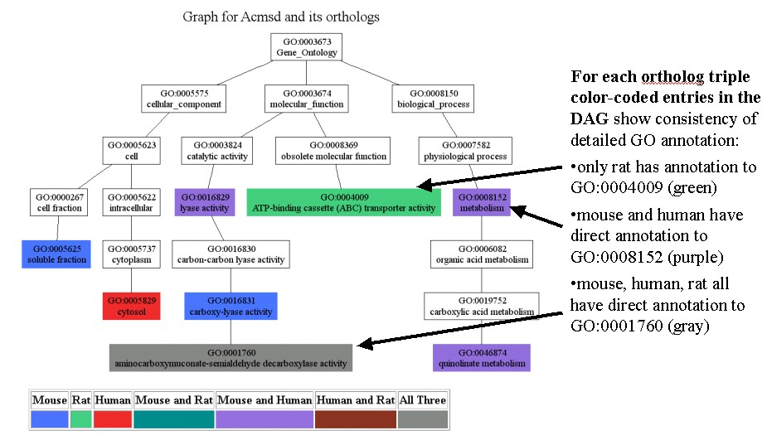
Figure 1. Annotation consistency

4. Other Highlights:

a. Developing human readable-text summaries of GO annotations
Chris , David, Alex, Harold
We have also been exploring the idea of generating narrative paragraphs generated from GO annotations. This would allow us to provide a more reader-friendly summary of the information that we know about a gene to our small-scale users. One of our summer students, Chris Hollenbeck, has created a prototype text-generator based on rules defined by field values in a GO annotation. The advantage of this approach over writing narrative statement by hand is that it permits automatic updates based on GO annotation, rather than text edits of the paragraphs themselves. An example is shown:
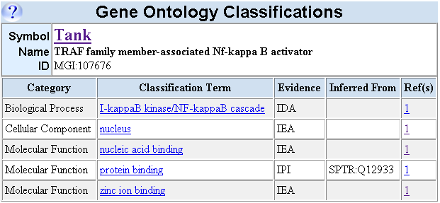
Before:

Figure 2 Annotations for Tank
After:
Tank encodes a protein or proteins that contain the following InterPro domains: Putative DNA binding and Zn-finger, C2H2 type. These domains imply that the gene product of Tank is in the nucleus. These domains also imply that the gene product has nucleic acid binding activity and zinc ion binding activity.
Research by Rothe et al suggests by a direct assay that the gene product is involved in the I-kappaB kinase/NF-kappaB cascade. Physical interaction experiments have indicated that the gene product of Tank binds the following: SPTR:Q12933 (TNF receptor associated factor 2, human).

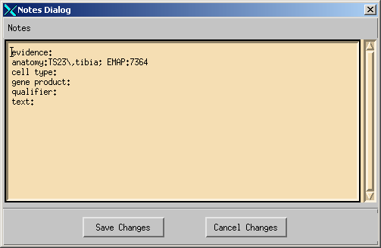
b. Structured Notes Fields
We have also implemented a structured notes field to include information about experiment type, gene products, anatomical and cell type information and free-text notes. This notes field allows us to annotate papers to the detail that the author uses when describing the data. See the abstract by David for more details.
Figure 3 GO editorial annotation notes

c. Protein-protein interaction network
Harold has been working on using the annotations to protein-binding (GO:0005515 and children) to construct protein interaction networks. If a mouse gene product is annotated to protein binding using an IPI code, and the “with” field has a Protein_ID associated with a another mouse marker, one can represent this graphically by connected nodes. Depending upon the number of these annotations and the number of proteins appearing in the “with “ field, this representation can become fairly complex. One of the fall outs of collecting the data was that we saw instances of missing annotation (either non-reciprocal pairs, or missing entries in the “with” field.
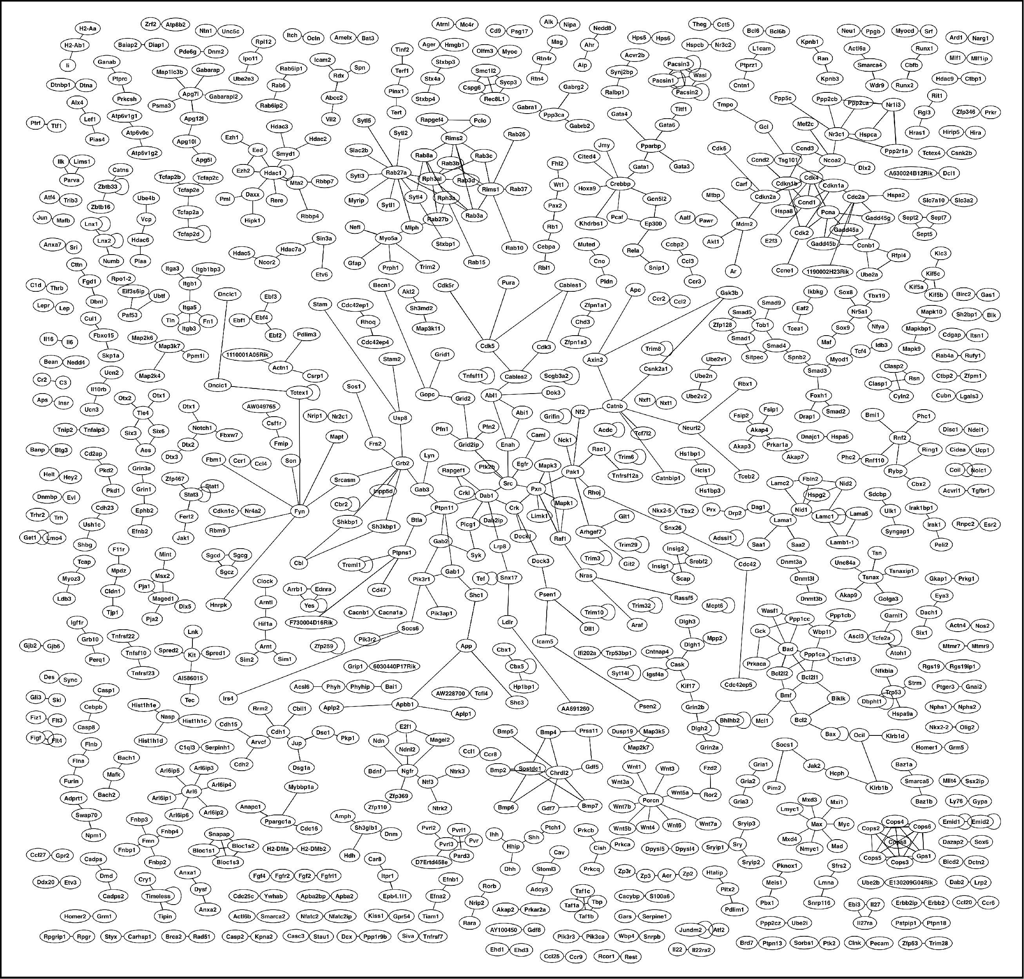

Figure 4 Murine protein-protein interactions represented by GO annotation

Number of genes with at least ONE GO term of any kind.
This figure has decreased due to our ongoing efforts to replace these with literature-based annotation.

