GO Editorial Office – EMBL-EBI

Progress Report, Stanford meeting, Jan 2004

Summary of changes to ontologies since last meeting:

 | Number end Sept 2003 | Number mid-January 2004 | Number new | % change
component | 1333 | 1377 | 44 | 3.3
process | 7779 | 8133 | 354 | 4.6
function | 7052 | 7267 | 215 | 3.0
total | 16168 | 16781 | 613 | 3.8
defs | 13781 | 14602 | 821 | 6.0
 |  |  |  | now 87% defined

Other news highlights

- Improved side index for webpage now live.

- NAR paper published “The Gene Ontology Consortium. 2004. The Gene Ontology (GO) database and informatics resource. Nucleic Acids Res 32: D258-D261”.

- Annotation issues and GO website trackers now up and running on SF: https://sourceforge.net/tracker/?group_id=36855

- SOP now in place for submitting new GO tools: http://www.geneontology.org/GO.tools.add.html

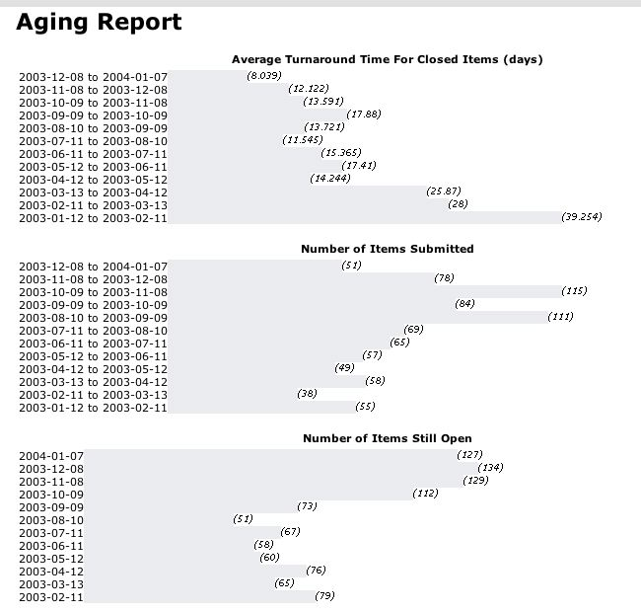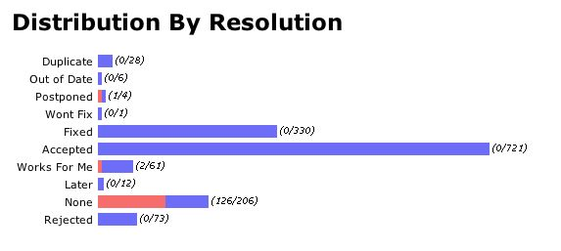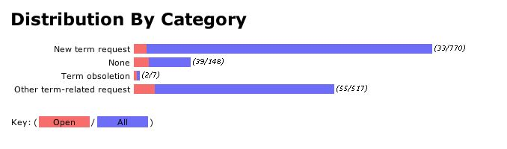

SourceForge Report

