GO REPORT FROM RGD

Bar Harbor, 9/26/03

GO annotations at GO
Total | 4968
Process | 2079
Function | 1815
Component | 1074
# genes annotated | 1449
GO annotations curated but not in db (as of ~9/22)
Total | 733
Process | 225
Function | 394
Component | 114
# genes annotated | 545
Total GO annotations
Total | 5701
Process | 2304
Function | 2209
Component | 1188
# genes annotated | 1855

We have a new GO curator, Victoria Petri, from Northwestern University.

We introduced GO to many members of the rat community at a symposium held in conjunction with the rat meeting in Kyoto, Japan. We also continue to present posters on the integration of GO into RGD.

We have implemented an ontology browser that integrates several ontologies (currently, gene, disease, phenotype, and pathway). This allows searching across all ontologies at the same time.

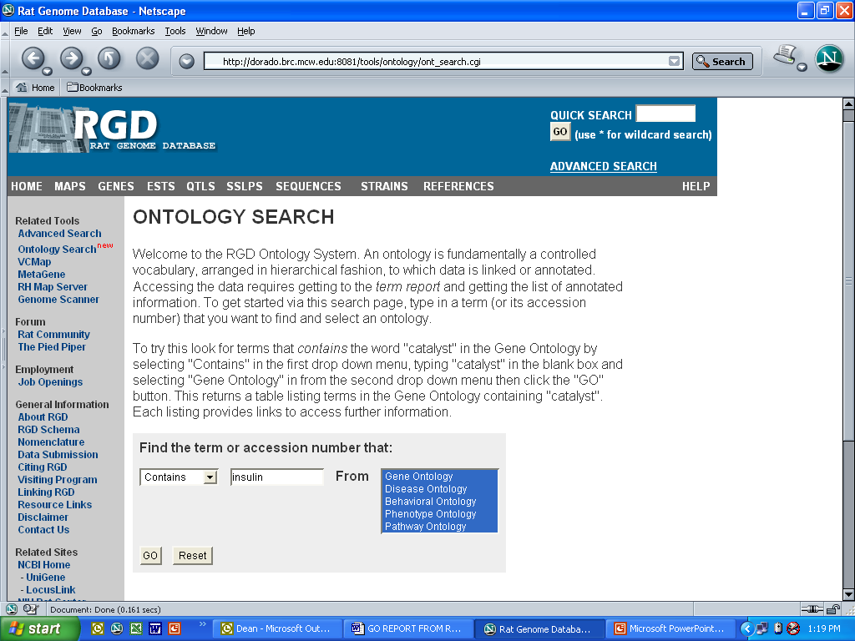

RGD Ontology Browser for gene, disease, phenotype, and pathway.

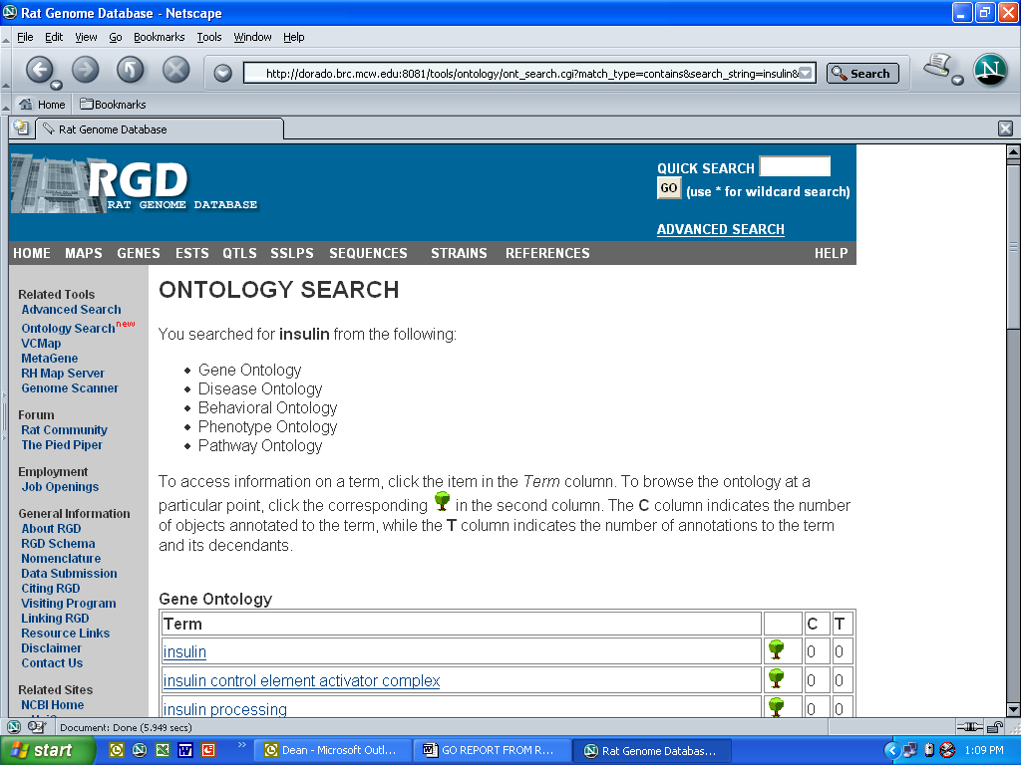
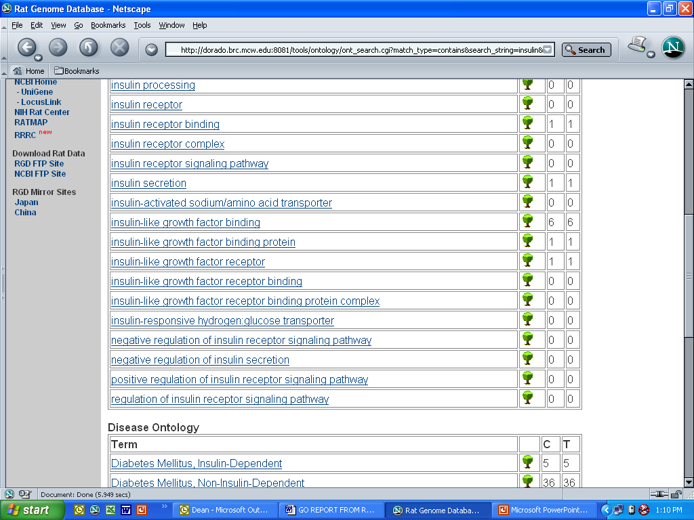
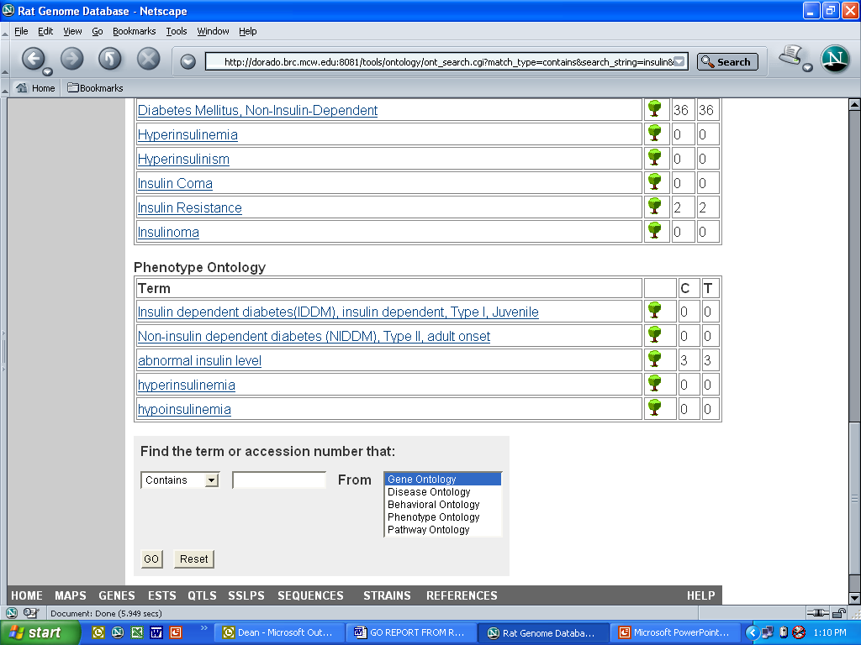

Search result covering 3 ontologies

