GO Consortium Meeting
St.Croix, April 2005
ZFIN representatives:
Doug Howe, Ph.D

Status Report for the Zebrafish Information Network (ZFIN)

1. Staff Contributing to GO Annotation:
Average FTE for GO since April, 2005

Curators
Doug Howe: ~0.5 FTE
Ceri Van Slyke: ~0.1 FTE
Dave Fashena: ~0.1 FTE
Erik Segerdell: ~0.05 FTE
Leyla Bayraktaroglu: ~0.15 FTE
Sridhar Ramachandran: ~0.05 FTE
Melissa Haendel ~0.1 FTE

Software Developers
Peiran Song: <0.05 FTE

DBAs
Sierra Taylor: <0.05 FTE

Our curators are each responsible for extracting all data types from the papers they curate, as well as overseeing and participating in new project development. I’ve estimated how much FTE each person has contributed to GO curation and development since April, 2005. On average, 10% of literature curation time is devoted to GO. There has been no significant GO software development at ZFIN between April, 2005 and April, 2006.

Annotation Progress:
Annotation summary for March 2, 2005-April 5, 2006
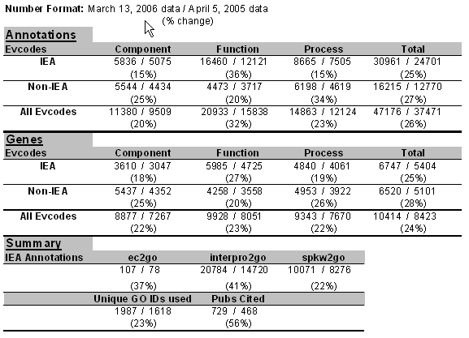

Annotation Methods:

a) Literature Curation:
ZFIN currently has 8 curators, and will add 2 more in the first half of 2006. Currently all of them split their time between project management / development activities and literature curation for all data types, including GO. As a result, only a fraction of each curator’s time is spent on GO curation. To promote correct GO annotation we have frequent discussions and we all read the GO Annotation email list. I (Doug) have begun to provide a monthly email digest to all the curators elaborating on questions and difficult annotation issues uncovered during the month. Monthly GO meetings of ZFIN curators were not effective and, contrary to my wishes, have been discontinued for the time being.

b) Computationally Assigned GO Annotation:
GO annotations are assigned to genes in ZFIN by applying spkw2go, ec2go, interpro2go. The SP keywords, ec #s, and Interpro domains are obtained from UniProt during our ~quarterly upload of data from UniProt.

c) Quality Control:
Currently operating QC methods include.
1. Nightly updates of the GO terms and IDs we store locally for use on our public displays and curatorial interfaces.
2. Nightly reports to me (Doug) of any annotations in our database that use obsolete or secondary GO IDs. I update (non-IEA) or delete (IEA) these as they occur.
3. Fresh gene_association and gp2protien files are produced every Sunday night. The gene_association.zfin file is checked using the filter script provided by GO as well as a local script to check for questionable annotation formats such as IDA annotations with inference data. Questionable annotations are reviewed with the curator who made them and corrected as necessary before I commit the final weekly update of the gene_association file and gp2protein file to the GO CVS.
4. Obsolete/secondary GO IDs are filtered out of translation tables before we apply them locally.

Ontology Development:
We have contributed a handful of new terms, and continue to make contributions through SourceForge as needed to accommodate zebrafish or to improve the quality of GO when possible. We have been actively involved in discussions of the GO development node and neurobiology oriented GO request, as these terms are frequently used by our group.

Recently active areas of development to which we have contributed include:
neural tube development
neural crest cell differentiation
pigment cell differentiation
neurogenesis & gliogenesis
axonogenesis/sprouting
neurotransmitter reuptake

Neurodevelopment Focus Meeting
David Hill, Cynthia Smith, Judy Blake and myself (Doug) are planning a neurodevelopment focus meeting to be held (most likely) June 14/15th at MIT.

Other Highlights:
Nothing significant.

