Berkeley Drosophila Genome Project (BDGP) - Progress Report
Gene Ontology Consortium Meeting, CalTech. April 8th – 9th, 2005.
This report is intended to be read in conjunction with the NIH 2004 progress report, as it largely focuses on work that has taken place since December to the present.

Ontology Quality Assuance
OBOL: In the first year or two of its existence, the GO was built using general-purpose text editors. Many problems were solved when we moved to a more convenient, specialized editor, which is well maintained and regularly enhanced to meet the curator’s needs (see below for bug fixes and enhancements). However, the structure of the GO was still essentially maintained manually.
Therefore, we have focused some efforts on building more automated means to maintain the consistency, quality, and integrity of the ontology: tools that will assist the curators in validating the GO. We instituted a major change to our file format in 2004, switching over to the new OBO file format as our primary format for editing in March, 04. The OBO format has several major advantages over the old flat file format, including easier parsing, improved extensibility and smaller file sizes. Files are still generated monthly in the older flat file format for those still using this system. The OBO file format also greatly simplifies the management of the GO_slims, high-level grouping terms of biological interest, because these are now included in OBO file, and are therefore updated automatically in line with the ontologies. The new format also enables running a new tool for QC: OBOL (Mungall 2004). Since we last met we have run OBOL over the GO on three occasions (in the penultimate and last run 350 and 290 missing parentage links respectively were uncovered, confirmed and fixed). Based on the number of problems this has detected, it is clear it helps.
As a result of what we learned in this pilot study, we have some direct questions for the board members.
One obvious thing is that the complexity of the problem is unavoidable. There are two polar extremes that may be taken, and everything that lies in between; the question is where, along this continuum, is the optimum position to contain this inherent complexity. In the original, and current, structure of the GO, all the complexity is shoved into the ontology itself. In that strategy, the most fundamental problem is that eventually, as the size of the ontology grows (the growth in the number of terms is shown in the figures below), its integrity and consistency falls apart: and therefore gene product queries will be inaccurate. In addition there are difficulties in navigating, visualizing, and understanding such a complex ontology (one with many different types of both direct and implied relationships). At the opposite extreme, the ontology consists only of very simple, pure subsumption ontologies (a single type of relationship), and the onus is borne by the annotator, who must construct complex terms for every annotation: concatenating terms from the simplified ontologies. Neither of these solutions eliminates the complexity, and there are recognizable trade-offs that are inherent in each approach.
Our proposal is to create and maintain a number of atomic ontologies. We may not fully decompose the existing ontologies, or we may gradually increase the decomposition over time. That is, we would first tease out cell types, then chemicals, then anatomical structures, and so forth. In addition to these base ontology we would also instantiate every term that exists now, and also allow for new terms to be instantiated that are composed from combinations of existing terms. By making the composed terms persistent, the ontology would be backwards compatible with existing software. Yet, by decomposing to more fundamental terms we will also be able to improve the consistency and structure of the ontology. We would like the board’s opinions on the middle road approach we are proposing.
However, it does not solve certain other problems. Because the composed terms would be instantiated the resulting ontology would still be very complex (any term could have many possible relationships to other terms) and therefore we still have the issue of presentation, navigation, and comprehensibility facing us.
Our second question is where to draw the line at composing terms that will be instantiated? Does it really make sense to instantiate a term combining a biological process, occurring in a given cell type, in a particular anatomical structure, during a particular developmental stage, and so on? Where is the natural boundary, between a combination that can be construed as a single term, and a more complex annotation using many terms?
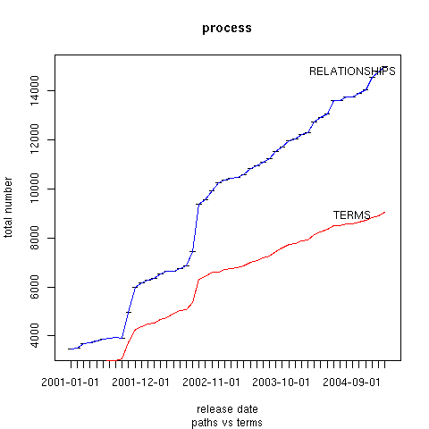

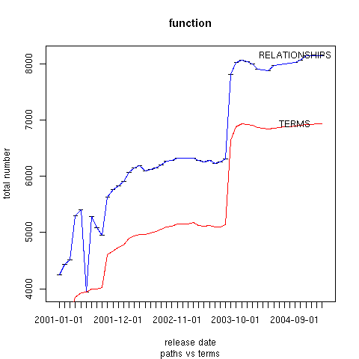

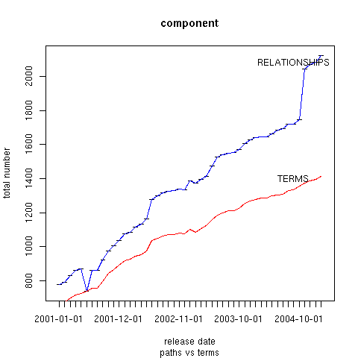

SO Ontology
The progress on SO is largely reported in the NIH progress report (also attached). Two papers were written and accepted for publication, and are listed with the other publications. We have also added information on the mapping between Genbank features and SO terms, and made this available both on the web site and for download.

GO Database
This portion of the report is included in the Stanford section.

AmiGO
Since last year in April over 400 bugs have been fixed and many new features have been added to AmiGO. There was a period of several months during this time when we did not have a developer available (July–November), so we are satisfied with this progress. Now that we once again have a full-time developer available we are initiating new work to improve the graphical representation of the mesh of relationships to make the structure of the ontology transparent and easy to use. This is an excellent opportunity to hear the board’s suggestions and help us set our priorities before any new projects commence on the web query interface.

OBO-Edit
OBO-Edit has successfully been installed at a number of other sites and has been used to support other ontologies as well. These include phenotypes, chemicals, anatomies, sequence features, and developmental stages. OBO -Edit’s development is geared towards flexible support for many different ontology representations, including OBO. DAG-Edit now provides support for the OBO 1.2 specification, which includes concepts that are essential for OWL compatibility (such as union, intersection, anonymous classes, and instances). We have implemented several significant changes to OBO-Edit in recent months. These will provide a robust base for the development of other application front-ends. Specifically we have implemented:
- Full support for synonym categories, intersections, and instances.
- Entirely redesigned internal data models, based on a rich, granular interface system. All data model objects are now instantiated through object factories, individually provided by each data-adapter. This allows data adapters easily to offer their own implementations of the basic OBO-Edit data structures. This will enable the creation of data model objects with new, useful characteristics, such as real-time communication with databases as objects are edited (essential to support interactive validation checks). Default, in-memory implementations of all OBO-Edit data models are also provided.
- Redesigned utility libraries: These are used for a number of low-level tasks, including cross-platform drag and drop, and many other functions. The new utility library is smaller, faster, and more memory efficient. It also takes full advantage of the features of Java 1.4 (e.g. the Java Collections Framework, advanced memory management techniques, and built-in XML support).
- Redesigned drag and drop: This allows drag and drop between any window in OBO-Edit, improved drag and drop graphics, and support for drag and drop animations.
- Friendlier cross-platform behavior. OBO-Edit offer several alternative ways of carrying out each editing task, with editing operations specified by standard drop down menus, right click menus, context-sensitive drag and drop menus, keyboard hotkeys, and drag and drop hotkeys. These different options enables users to work in the way they are most comfortable, using methods that are accessible and intuitive for the user's platform.
- Even more interface customizability. Users can now customize screen layouts, create and place custom popup windows on startup, and customize the basic OBO-Edit menus.
- Support for instance data through instance editor kits. Because instance data is highly variable, no single editor is appropriate for all instance data. OBO-Edit supports plug-able instance editor kits that will provide custom editing tools for different types of instance data.
- Includes wide support for reasoning tools. OBO-Edit now comes complete with a basic reasoning engine. This allows users to see the logical implications of (and potential mistakes in) the ontologies they have designed in real time. OBO-Edit is designed for tight integration with OBOL, the prolog-based OBO ontology reasoning tool. OBO-Edit also provides interfaces for plugging in third-party reasoning tools like Racer.

