Staff:
Curators: Alexander Diehl, Harold Drabkin, Mary Dolan, David Hill, Li Ni,
Pis: Judith Blake, Janan Eppig, Jim Kaden , Joel Richardson, Martin Ringwald,

General:

1. We continue our efforts at hand annotation for genes currently without GO annotation (Li), and we continue to add further annotations the other genes, paying particular attention to genes with only IEA.

MGI GO STATS as of Jan, 4

Annotation Type | 6-Jan_04 | 22-Sept_03 | Change | % Change
Total Genes annotated: | 12761 | 12682 | 79 | 0.6
Total Hand Annotation
Number of Genes | 4804 | 4497 | 307 | 6.8
Orthology: | 33 | 32 | 1 | 3.0
“IEA”
SwissProt to GO | 7488 | 7192 | 296 | 4.1
Interpro to GO | 4513 | 4238 | 275 | 6.4
EC to GO | 651 | 651 | 0 | 0
MLC Scan | 40 | 40 | 0 | 0
GO Fish | 2131 | 2152 | -21 | -1

2. Alex has been working with Evelyn to extensively define and edit the ontology related to immunological processes.

3. David and others have been working on separating physiological process into two main branches: organismal physiological process and cellular physiological process.

4. Harold has worked with Jane on reorganizing the protein biosynthesis node. He was also a participant of the recent DAG-editor workshop.

5. We now filter out redundant IEA annotations derived from SP2GO and IP2GO translations if there are hand annotations supporting the same GO ID. This will effect not only the web display, but also the MGI association file.

Current GO-Slim View of Annotations at MGI.
(Derived from GO_Slim Chart tool, by Mary Dolan http://www.spatial.maine.edu/~mdolan/MGI_GO_Slim_Chart.html)

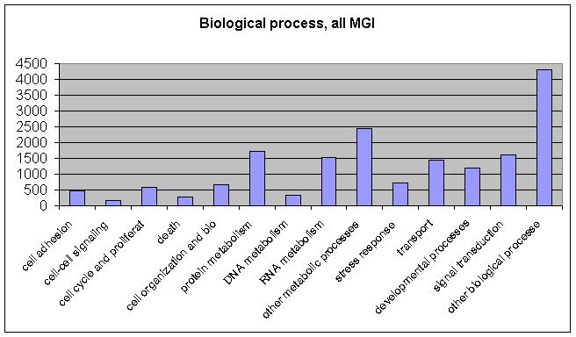

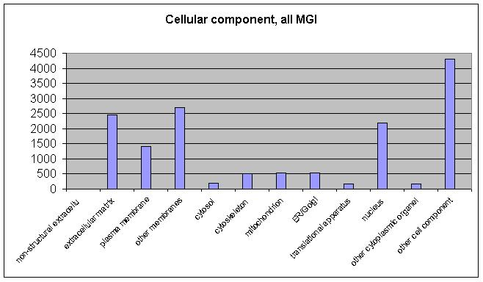

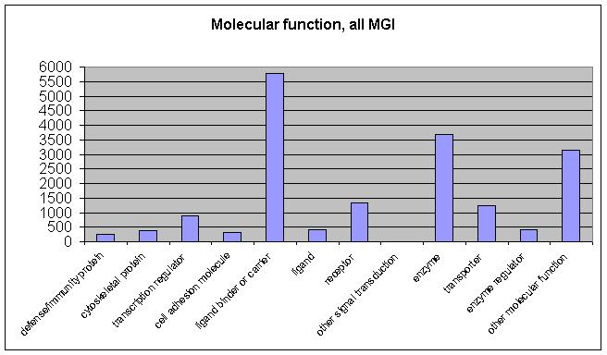

Number of genes with at least ONE GO term of any kind.
This figure has decreased due to our ongoing efforts to replace these with literature-based annotation.

