**Appendix 1: Request for Expert Panel or Practice Guideline**

**Designation for Submissions to ClinVar**

|  |  |
| --- | --- |
| **Submitter Information** | |
| **Full Name of Submitting Source**: Click here to enter text. | |
| **Acronym or other brief name for ClinVar data display**: Click here to enter text. | |
| **Expert Panel Member responsible for submission**:  Click here to enter text. | |
| **Email address**: Click here to enter text. | **Phone**: Click here to enter text. |
| **Expert Panel Coordinator and email address:** | |

**ClinGen – affiliated groups** should compose their Expert Panel application in accordance to the below timeline. ClinGen affiliated groups are required to submit for Step 1 approval after completing items A-C. Similarly, after completing item D, ClinGen-affiliated groups are required to send their variant classification rules to the Sequence Variant Interpretation (SVI) WG. Finally, ClinGen groups will pilot and refine rules, format their first ClinVar submission, and define a protocol for ongoing variant curation (complete items E-G) and submit for Step 3 (final) approval by ClinGen's Steering Committee (SC).

**External Expert Panel applicants** are also suggested to complete their Expert Panel application in a stepwise manner, in accordance to the timeline shown below. We encourage these groups to begin communication with ClinGen’s Clinical Domain WG Oversight Committee (after Step 1) and SVI (after Step 2) early in the application process. All Expert Panel applicants are required to submit for Step 3 (final) approval by ClinGen's Steering Committee.

Groups applying for **Practice Guideline** (4-star) status in ClinVar should contact ClinGen at [clingen@clinicalgenome.org](mailto:clingen@clinicalgenome.org) for the Practice Guideline application.

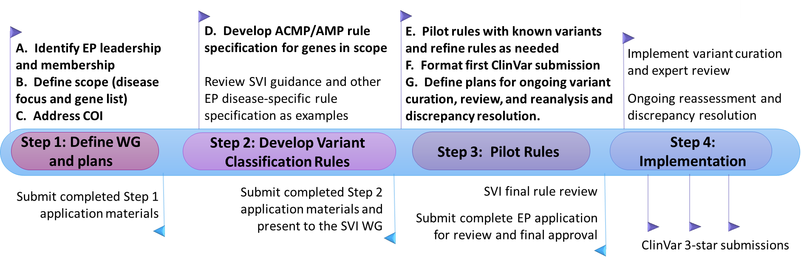

|  |
| --- |
| **Expert Panel Submission Details** |

|  |  |  |  |
| --- | --- | --- | --- |
| **A.** **Composition of the Expert Panel** | | | |
| *Expert Panels are expected to represent the diversity of expertise in the field, including all major areas of expertise (clinical, diagnostic laboratory, and basic research). Membership should include representation from three or more institutions and will encompass disease/gene expert members as well as biocurators. Biocurators do not have to be gene/disease experts and will be primarily responsible for assembling the available evidence for subsequent expert member review. For role, suggested examples include: primary biocurator, expert reviewer, etc.* | | | |
| **Member List** | | | |
| **Name** | **Institution** | **Area and Type of Expertise** | **Role** |
|  |  |  |  |
|  |  |  |  |
|  |  |  |  |
|  |  |  |  |
|  |  |  |  |
|  |  |  |  |
|  |  |  |  |
|  |  |  |  |
|  |  |  |  |
|  |  |  |  |
|  |  |  |  |
|  |  |  |  |
|  |  |  |  |
|  |  |  |  |
|  |  |  |  |
|  |  |  |  |
|  |  |  |  |
|  |  |  |  |
|  |  |  |  |
|  |  |  |  |
|  |  |  |  |

(Insert additional page if needed)

|  |
| --- |
| 1. **Scope of Work** |
| **Describe the scope of work of the Expert Panel (disease areas and gene(s) being addressed).**  Click here to enter text |

|  |
| --- |
| 1. **Conflict of Interest Management** |
| *Expert Panels are expected to represent the diversity of expertise in the field and should be composed of a sufficient number of eligible expert reviewers to address academic and financial conflicts of interest that may arise.*   * + *Academic COI: Authors of literature about relevant variants may serve on the Expert Panel and are welcome to voice their opinion, but should not be the major arbiter of a variant classification when there is limited data available and it was provided by that individual or the individual’s lab group.*   + *Financial COI: Commercial entities may participate on the Expert Panel, but should not be the major arbiter of a variant classification when there is limited data available and it was provided by that entity.*   + *No special measures are needed if there is group consensus on a variant classification; however, if a vote is needed, those with relevant conflicts of interest should recuse themselves.*   + *All conflicts will be declared publicly on the clinicalgenome.org website and reported in publications as appropriate.* |



Date of

Submission:

__ / __ / ____

**Note to Submitters:** After completing Step 1 (application items A-C), please submit your draft Expert Panel application to the ClinGen Clinical Domain WG Oversight Committee (clingen@clinicalgenome.org) for review.

|  |
| --- |
| 1. **ACMG guideline specifications** |
| *Expert Panels are encouraged to use the ACMG/AMP variant assessment criteria as their starting point for a framework to adjudicate Mendelian variants according to the five class criteria (pathogenic, likely pathogenic, uncertain significance, likely benign, and benign). The Expert Panel process typically entails reviewing the evidence types and making gene-specific specifications to the ACMG/AMP guidelines, including consultation with the Sequence Variant Interpretation WG in order to facilitate harmonization of approaches across different expert panels.*  **Provide the gene-optimized rules for variant classification designed by the Expert Panel as an appendix. Documentation will be made publicly available and could consist of an unpublished document, manuscript pre-print, or published manuscript. The following items must be included in the submitted material:**   * + **Please attach a description of the specified ACMG/AMP guidelines for the gene(s) of interest, including evidence and rationale to support the rule specifications.** * **Describe combinations of rules and evidence sources that could be used to classify any categories of variants (e.g. Benign or Likely Benign) in a batch:** |



Date of

Submission:

__ / __ / ____

**Note to Submitters:** After completing Step 2 (application item D), please submit your draft Expert Panel application to the ClinGen Sequence Variant Interpretation Working Group (clingen@clinicalgenome.org) for review.

|  |
| --- |
| 1. **Validation of ACMG guideline specifications** |
| **Please provide a description of how your rules were validated with known variants.**  Click here to enter text. |

|  |  |
| --- | --- |
| 1. **Model ClinVar submission** | |
| *Expert Panels are encouraged to make submissions to ClinVar through the ClinGen Variant Curation Interface (VCI) in order to standardize the content across expert panels.*  **Please provide a sample list of classified variants curated in the VCI or attached in the ClinVar submission template. The submission template can be downloaded here:** [**ftp://ftp.ncbi.nlm.nih.gov/pub/clinvar/submission_templates/**](ftp://ftp.ncbi.nlm.nih.gov/pub/clinvar/submission_templates/)  Click here to enter text. | |
| 1. **Define plans for ongoing variant curation, review, and reanalysis and discrepancy resolution** |
| *Expert Panels are expected to develop work schedules, review and resolve differences in interpretation, and provide standard procedures for variant assessment.*  **Standard Operating Procedures:**   * + **Meeting/call frequency:** Click here to enter text.   + **Curation/expert review/finalization process:**   ☐ **Version 1: One curator performs data entry and baseline curation; two domain experts perform blinded double review and classification. Discussions with the full EP are triggered if:**  **a) the experts do not reach consensus,**  **b) either expert raises concerns regarding the “fit” of a rule, or**  **c) the strength of functional evidence needs further input.**  ☐ **Version 2: Two curators perform independent assessments followed by full EP review and consensus classification.**  ☐ **Other** |
| *Expert Panels are expected to keep their variant interpretations up-to-date and to expedite the re-review of variants that have a conflicting assertion submitted to ClinVar after the Expert Panel submission*.  ☐ **Expert Panels are expected to contact the submitter of a newly submitted conflicting assertion in ClinVar from a one star submitter or above and attempt to resolve or address the conflict within 4 months of being notified about the conflict from ClinGen**  ☐ **Expert Panels are expected to re-review all VUS classifications made by the EP at least every 2 years to see if new evidence has emerged to re-classify the variants**  ☐ **Expert Panels are expected to re-review any LP or LB classifications when new evidence is available or when requested by the public via the ClinGen website.**  ☐ **If plans differ from the expectations above, please describe here:** |

**Note to Submitters:** Please send your completed Expert Panel application to ClinVar (clinvar@ncbi.nlm.nih.gov) and to the ClinGen Clinical Domain WG Oversight Committee (clingen@clinicalgenome.org) for review.

P

Date of Final

Submission:

__ / __ / ____

**Appendix 2: Frequently Asked Questions**